**Shipease 2.0 Documentation**

Table of Contents:

1. Introduction

2. Dashboard

3. Orders

4. More On Orders

5. Shipments

6. Integration

7. Billing

8. Weight Reconciliation

9. Customer

10. Tools

11. MIS

12. Customer Support

## Introduction

The Logistics Dashboard is a comprehensive tool designed to provide insights and control over various aspects of the logistics operations. This documentation aims to guide users through the functionalities of the dashboard, helping them effectively manage and optimize logistics processes

## Dashboard

The Dashboard Overview section provides Information about the progress and performance indicators related to logistics operations. Users can quickly assess the overall status and performance of the logistics processes

Key Components:

• Performance Charts

• Real-time Status Update

• Overview Metrics

• Total Shipment

• Revenue Analytics

• Courier Wise Allocation

• Delivery Performance

• Last 30 days

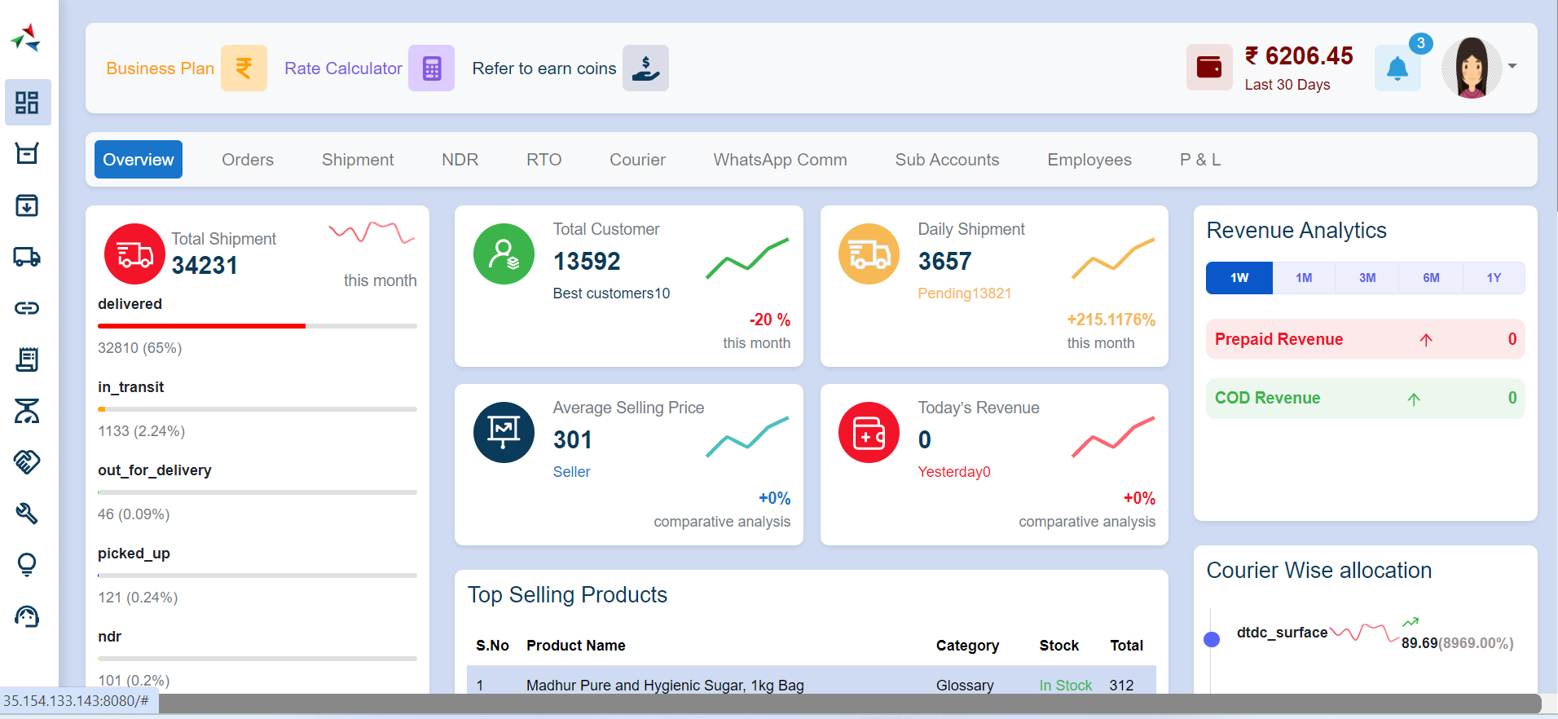

### 2.1 Overview

### 2.1.1 Total Shipment

The Total Shipment metric represents the overall count of shipments processed within the specified time frame

### 2.1.1.1 Delivered

The "Delivered" status indicates that the shipment has reached its destination and has been successfully handed over to the customer

### 2.1.1.2 In Transit

"In Transit" signifies that the shipment is currently in the process of being transported from the seller to the destination

### 2.1.1.3 Out for Delivery

"Out for Delivery" indicates that the shipment has reached the destination area and is scheduled for delivery to the customer

### 2.1.1.4 Picked Up

Picked Up" represents the status where the logistics provider has collected the shipment from the seller's location and initiated the transportation process

### 2.1.1.5 NDR

"NDR" or Non-Delivery Report is triggered when a shipment cannot be delivered to the customer successfully. This status indicates that delivery attempts have failed, and sellers may need to take corrective actions, such as updating customer details or coordinating with the logistics provider for reattempting delivery

### 2.1.1.6 Shipped

Shipped" denotes that the seller has processed the order, and the shipment is prepared and handed over to the logistics provider for transportation. This status indicates that the shipment is in the early stages of the delivery process

## 2.1.2 Total Customer

The "Total Customer" metric represents the overall count of unique customers who have engaged with the seller's products or services. It provides sellers with an at-a-glance view of the size and growth of their customer base

### 2.1.2.1 Best Customer

The "Best Customer for the Month" identifies the customer who has exhibited the highest level of engagement, such as making the most significant number of purchases or generating the highest revenue for the current month

## 2.1.3 Daily Shipment Overview

The Daily Shipment and Pending Information Documentation provides sellers with a comprehensive understanding of shipment-related metrics within the Seller Dashboard

### 2.1.3.1 Daily Shipment

The "Daily Shipment" metric represents the total number of shipments processed by the seller on a daily basis

### 2.1.3.2 Pending Shipments

"Pending Shipments" refer to the number of orders that have been received but not yet processed for shipping. This metric highlights the orders that are in the queue and require the seller's attention for fulfilment

## 2.1.4 Average Selling Price

The "Average Selling Price" metric represents the average monetary value at which products or services were sold by the seller within a given month. This metric is valuable for assessing the overall pricing strategy and understanding the typical transaction value for the seller's offerings

## 2.1.5 Today's Revenue

The Today's Revenue Information Documentation provides sellers with insights into the total revenue generated on a daily basis over a specific month within the Seller Dashboard. This documentation aims to guide sellers in understanding and utilizing the Today's Revenue metric for informed decision-making

## 2.1.6 Revenue Analytics Overview

"Revenue Analytics" encompasses the overall financial performance of a seller's products or services. This includes various revenue streams and provides a detailed breakdown of revenue sources, such as Prepaid Revenue and COD Revenue

### 2.1.6.1 Prepaid Revenue

"Prepaid Revenue" represents the total monetary value of products or services for which payment has been made in advance by customers

### 2.1.6.2 COD Revenue

"COD Revenue" represents the total monetary value of products or services for which payment is collected upon delivery. This includes transactions where customers choose to pay in cash when the product is delivered to their doorstep

## 2.1.7 Top Selling Products

"Top Selling Products" refer to the products that have achieved the highest sales volume or generated the most revenue within a given month. This metric helps sellers identify which products are performing well and contribute significantly to overall sales

## 2.1.8 Courier Wise Allocation

The Courier Wise Allocation Information Documentation provides sellers with insights into the distribution of orders among different courier services for a specific month in the Seller Dashboard. This documentation aims to guide sellers in understanding and optimizing their courier allocation strategies for efficient order fulfillment

## 2.1.9 State Wise Split

State Wise Split refers to the categorization of orders based on the states or regions to which they are being shipped. This segmentation allows sellers to analyze order distribution patterns, identify regional trends, and tailor their logistics strategies for improved efficiency

## 2.1.10 Weight Discrepancies

Weight Discrepancies refer to differences between the expected or declared weight of a product or shipment and the actual measured weight. These variations can occur due to factors such as inaccurate measurements, packaging materials, or data entry errors

## 2.1.11 Most Popular Customer

The Most Popular Customer is the customer who has demonstrated the highest engagement, frequent purchases, or significant contribution to sales within a given month. Identifying and understanding these customers is essential for building lasting relationships and maximizing customer retention

## 2.2 Orders

The Orders section allows users to manage and track orders from initiation to delivery. This includes channel by orders, monitoring order status, and managing order-related tasks

Features:

• Channel by Order

• Order Status Tracking

• Popular Order Location

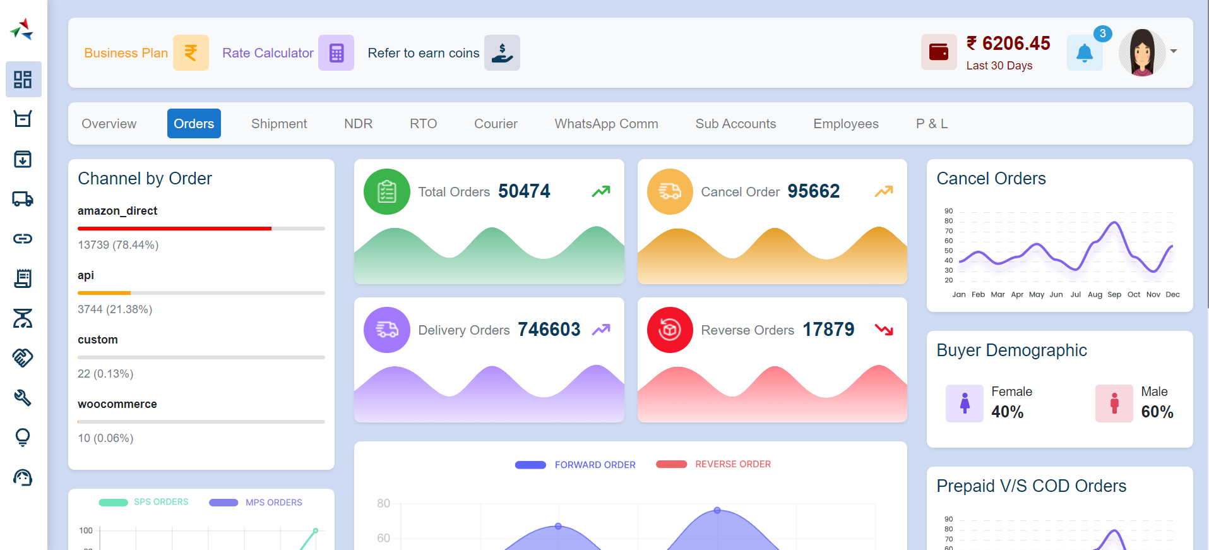

### 2.2.1 Store Based Orders

Channel by Order represents the distribution of orders across different sales, channels or platforms

### 2.2.2 Total Orders

Total Orders represent the overall number of orders placed during the specified month

### 2.2.3 Cancel Orders

Cancel Orders represent the number of orders cancelled by either the seller or the buyer

### 2.2.4 Yet To Pick

Delivery Orders represent successfully delivered order

2.2.5 Reverse Order

Reverse Orders represent orders that have been returned by customers

### 2.2.6 Buyer Demographic

Buyer Demographic provides insights into the characteristics of the customer base, including location, and gender

### 2.2.7 Prepaid vs COD Orders

Prepaid vs COD Orders compare the number of orders paid in advance with those paid upon delivery (Cash on Delivery)

### 2.2.8 Popular Order Location

Popular Order Location identifies regions or locations with the highest order volumes

### 2.2.9 Warehouse Information

Warehouse Information provides insights into the performance and inventory levels of different warehouses

### 2.2.10 Best SKU Products

Best SKU Products highlight the top-performing Stock Keeping Units (SKUs) based on sales volume or revenue

## 2.3 Shipment

The Shipment section focuses on managing the shipping process, ensuring timely and efficient delivery

Features:

• Shipment Scheduling

• Real-time Tracking

• Delivery Confirmation

• Shipment Analytics

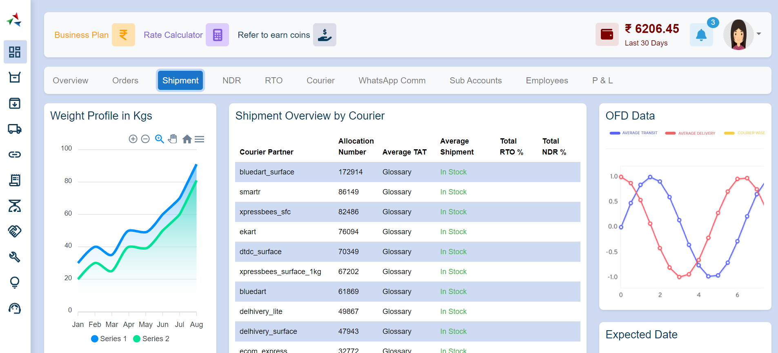

### 2.3.1 Weight Profile in kg

Weight Profile in kg provides insights into the distribution of shipment weights, highlighting the range and average weight of shipments

### 2.3.2 Shipment Overview by Courier

Shipment Overview by Courier presents a breakdown of shipments based on different courier services

### 2.3.3 OFD Data (Out for Delivery)

OFD Data represents the number of shipments that are currently out for delivery

### 2.3.4 Zone Wise Data

Zone Wise Data categorizes shipments based on geographic zones or regions

## 2.4 NDR

The NDR section deals with non-delivery reports, helping users understand and manage unsuccessful delivery attempts

Features:

• NDR Notifications

• Reason Analysis

• Redelivery Scheduling

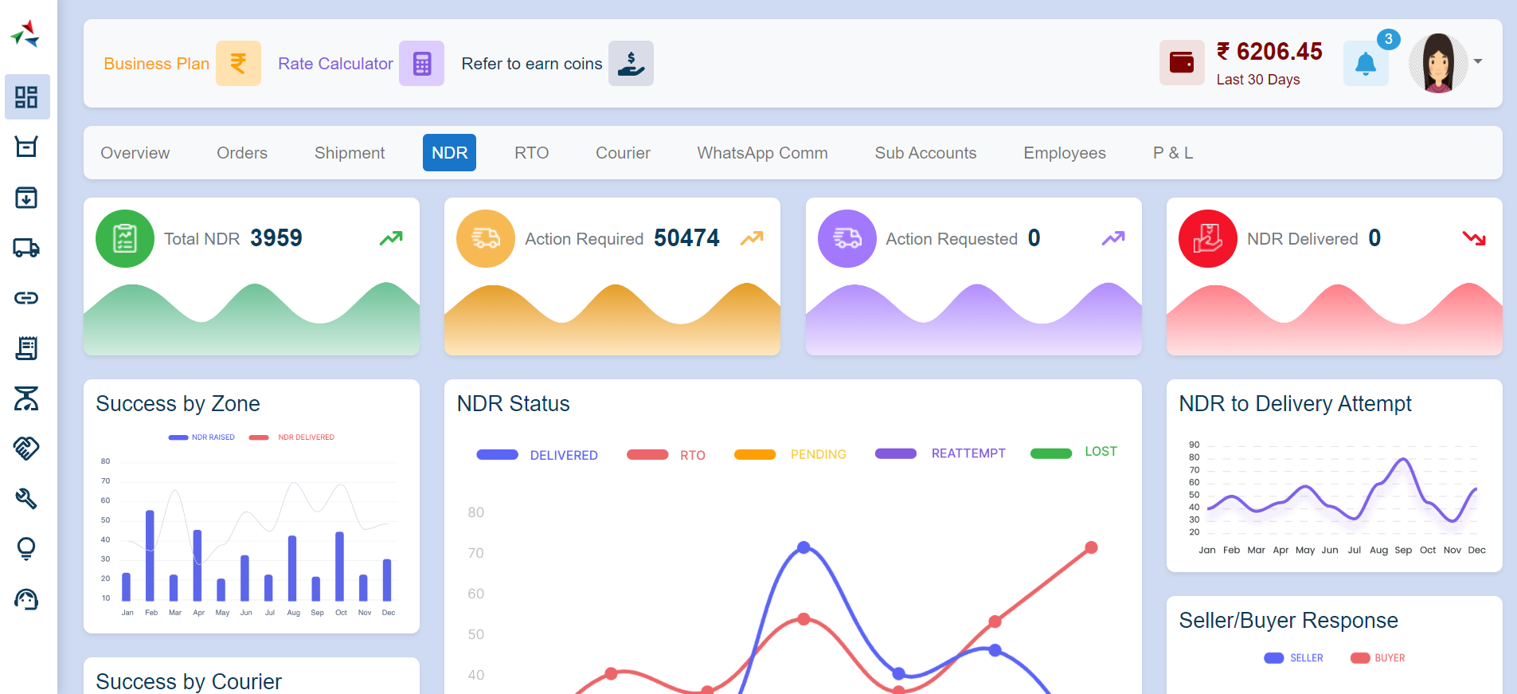

### Total NDR

Total NDR represents the overall number of non-delivery reports generated

### Action Required

Action Required indicates the number of non-delivery scenarios that require immediate attention or intervention. Identifies urgent cases that need resolution to prevent customer dissatisfaction

### Action Requested

Action Requested represents non-delivery scenarios where specific actions are requested for resolution

### NDR Delivered

NDR Delivered indicates the number of non-delivery reports that were successfully resolved and delivered

### Success by Zone

Success by Zone provides the success rates of resolving NDRs in different geographic zones.

### NDR Status

NDR Status categorizes non-delivery reports based on their current status (e.g., pending, resolved, in progress)

### NDR to Delivery Attempt

NDR to Delivery Attempt represents the ratio of NDRs to the total number of delivery attempts

### Success by Courier

Success by Courier provides success rates in resolving NDRs for different courier services

### NDR Reason Split

NDR Reason Split categorizes non-delivery reports based on the reasons for the unsuccessful delivery

### Seller Buyer Response

Seller Buyer Response indicates the responses from sellers and buyers regarding non-delivery scenarios

### NDR Response

NDR Response represents the overall response from both sellers and buyers in resolving non-delivery scenarios

## 2.5 RTO

The RTO section handles return-to-origin processes, providing control over returned shipments

**Features:**

* RTO Request Handling
* Return Authorization
* Restocking and Reshipping

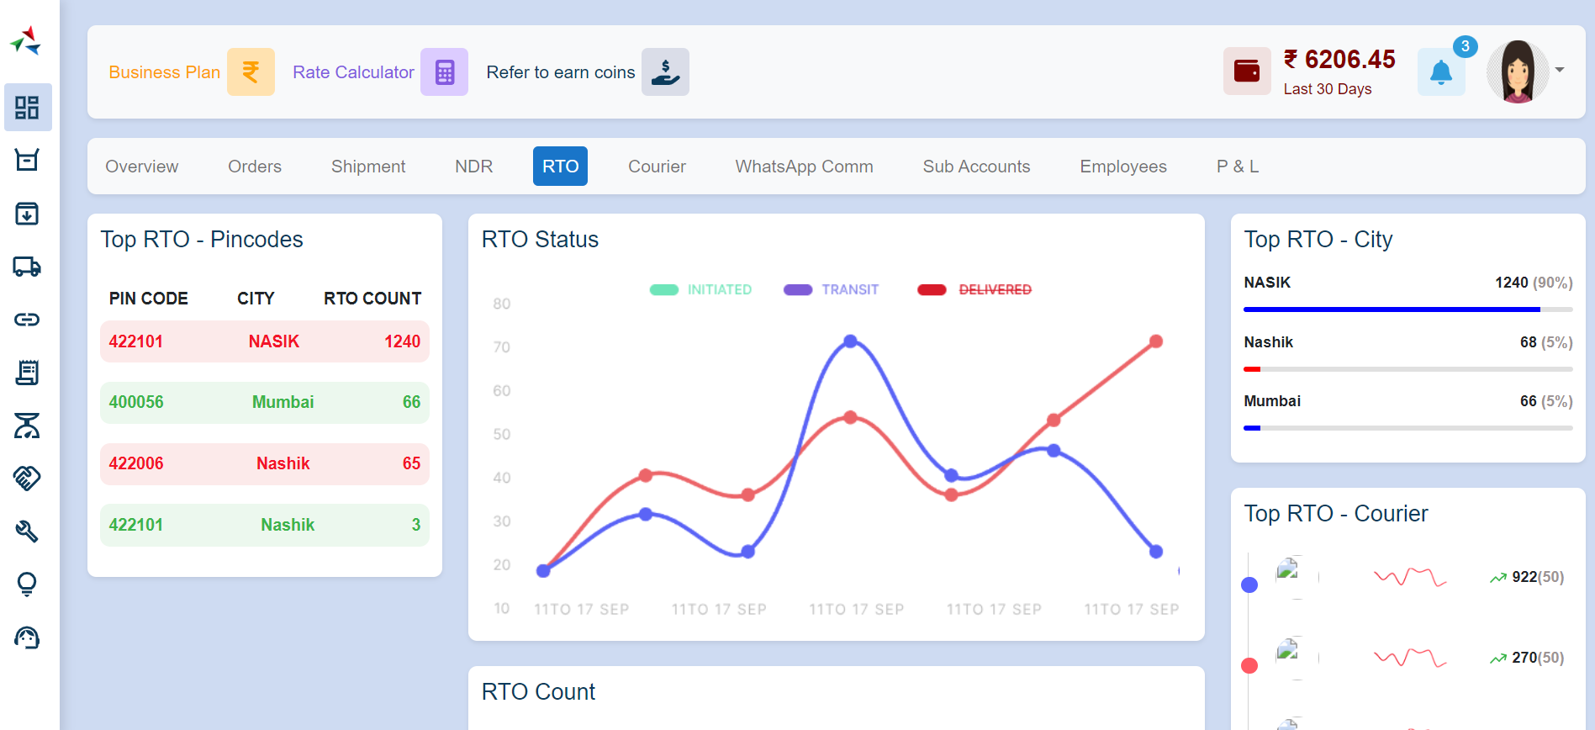

### 2.5.1 Top RTO Pincodes

Top RTO Pin Codes identify the postal codes with the highest occurrences of returns.

### 2.5.2 RTO Status

RTO Status categorizes returns based on their current status (e.g., pending, processed, in transit)

### 2.5.3 Top RTO City

Top RTO City identifies cities with the highest occurrences of returns

### 2.5.4 RTO Count

RTO Count represents the overall number of returns processed during the specified month

### 2.5.5 Top RTO Courier

Top RTO Courier highlights the courier services with the highest occurrences of returns

## 2.6 Courier

The Courier section integrates with courier services, facilitating streamlined logistics operations.

**Features:**

* Courier Selection
* Rate Comparison
* Label Generation
* Courier Performance Analytics

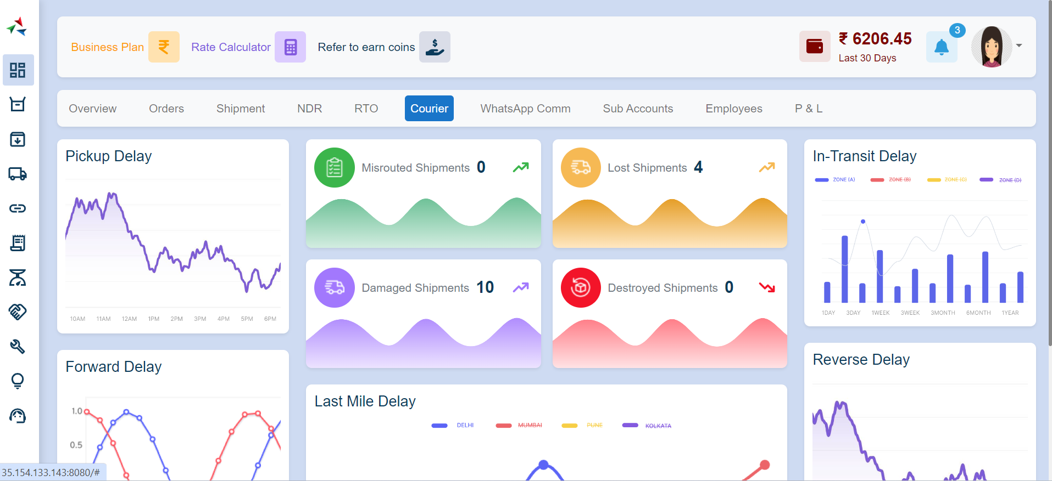

### Pickup Delay

Pickup Delay indicates instances where the courier service fails to pick up shipments within the specified time frame

### Misrouted Shipments

Misrouted Shipments represent shipments that are incorrectly routed during transit, leading to delays and potential delivery issues

### Lost Shipments

Lost Shipments indicate shipments that cannot be located and are considered lost in transit

### Damaged Shipments

Damaged Shipments represent shipments that incur damage during transit.

### Destroyed Shipments

Destroyed Shipments indicate shipments that are damaged and cannot be delivered

### Forward Delay

Forward Delay represents delays in forwarding shipments to the next logistics stage

### Last Mile Delay

Last Mile Delay represents delays in the final stage of delivery, typically the distance between the distribution centre and the delivery address

### In-Transit Delay

In-Transit Delay represents delays that occur while shipments are in transit between locations

### Reverse Delay

Reverse Delay indicates delays in the reverse logistics process, typically associated with returns

## 2.7 WhatsApp Communication

The WhatsApp Communication section enables communication through WhatsApp, enhancing customer engagement and support

**Features:**

* Order Updates via WhatsApp
* Customer Queries Handling
* Automated Notifications

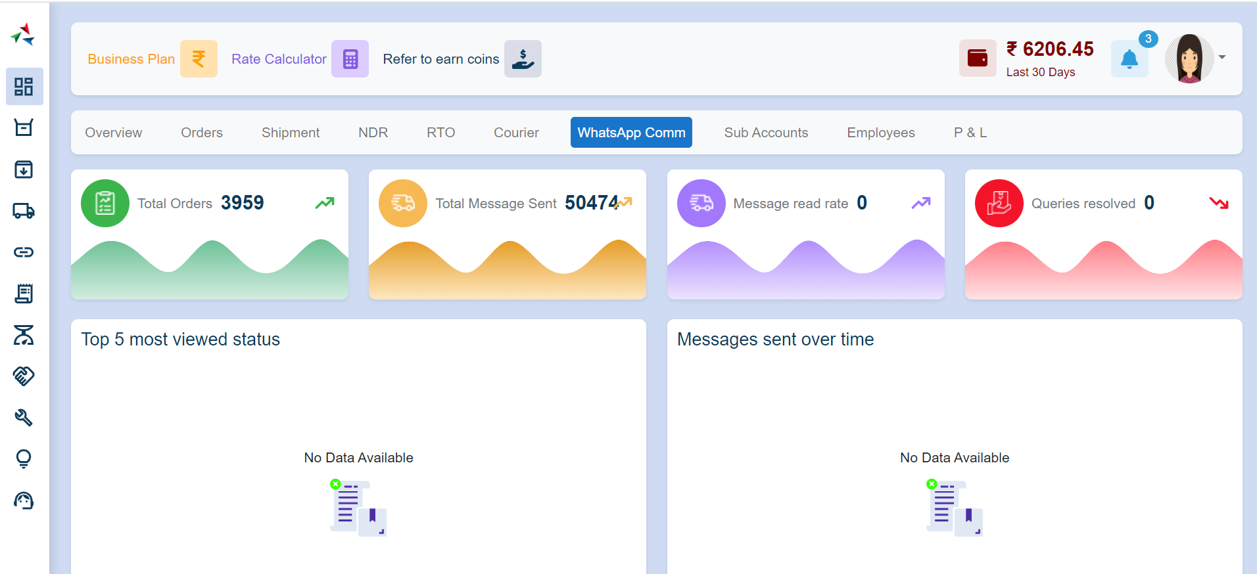

## 2.8 Sub Accounts

The Sub Accounts section allows the creation and management of sub-accounts, granting controlled access to specific users

**Features:**

* Sub Account Creation
* Access Control
* User Activity Monitoring

## 2.9 Employees

The Employees section focuses on managing and monitoring the activities of logistics team members

**Features:**

* Employee Profiles
* Task Assignments
* Performance Analytics

## 2.10 P & L (Profit & Loss)

The P & L section provides insights into the financial performance of logistics operations

**Features:**

* Revenue Analysis
* Cost Tracking
* Profitability Reports

## 3. Order

Order details guide users through various order-related processes, from creation to shipping and handling returns

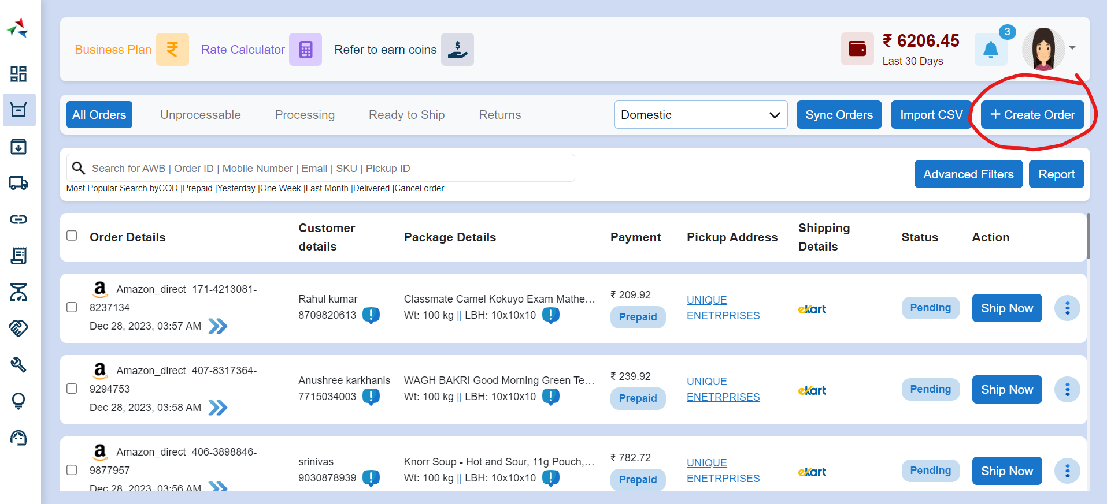

## 3.1 All Orders

The "All Orders" section provides an overview of all orders in the logistics system. It includes information on the order status, customer details, and order history

**Features:**

* Order Listing
* Status Overview
* Order Details
* Customer Information

## 3.1.1 Order Creation Process

The Order Creation Documentation outlines the step-by-step process for creating an order by passing essential information, including order details, shipping details, product details, package details, and warehouse details

### Order Details

Enter the general details of the order such as Customer Order No., Order type, Order Date, Order Channel, Payment Type, MPS (Multiple Packaging System) Details

### Shipping Details

Enter the shipping information for the order, including customer name, address, contact details

### Product Details

Specify the products included in the order, including product names, quantities, prices, product category, Weight and SKU details

### Package Details

Enter information related to packaging, such as package dimensions, weight, Invoice amount, COD charges and any special instructions

### Warehouse Details

Select the warehouse from which the products will be dispatched

### Submit Order

Finalize the order creation by reviewing all entered details and submitting the order

## **3.1.2 Advanced Order Filtering**

Users can filter orders based on start and end dates, payment options, order source, store name, channel, order ID, payment status, and product

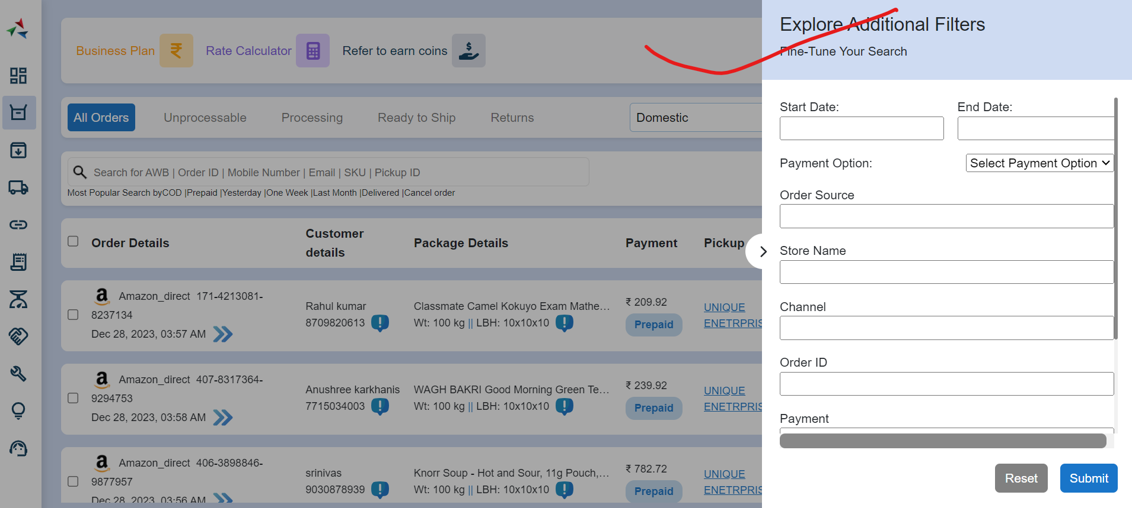

### **Filter Criteria**

Start and End Date

Users can specify a date range to filter orders created between the selected start and end dates

#### Payment Option

Users can filter orders based on payment options such as Cash on Delivery (COD) or prepaid

#### Order Source

Filter orders based on the source from which they originated, such as online, in-store, or a specific platform

#### Store Name

Filter orders by the name of the store associated with each order

#### Channel

Filter orders based on the sales channel or in-store

#### Order ID

Search for specific orders using their unique order ID

#### Payment

Filter orders based on their payment such as paid, pending, or refunded

#### Product

Filter orders based on specific products included in the order

### **Example:**

* Navigate to the Order section.
* Click on the "Advanced Filters" button.
* Set the desired filter criteria, such as start and end dates, payment options, etc.
* Click "Apply Filters" to update the order list.
* To reset filters and view all orders, click "Reset Filters."

3.1.3 Search Functionality

The search functionality allows users to quickly locate orders based on various search criteria, including Air Waybill (AWB), Order ID, Mobile Number, Email, SKU (Stock Keeping Unit), and Pickup ID

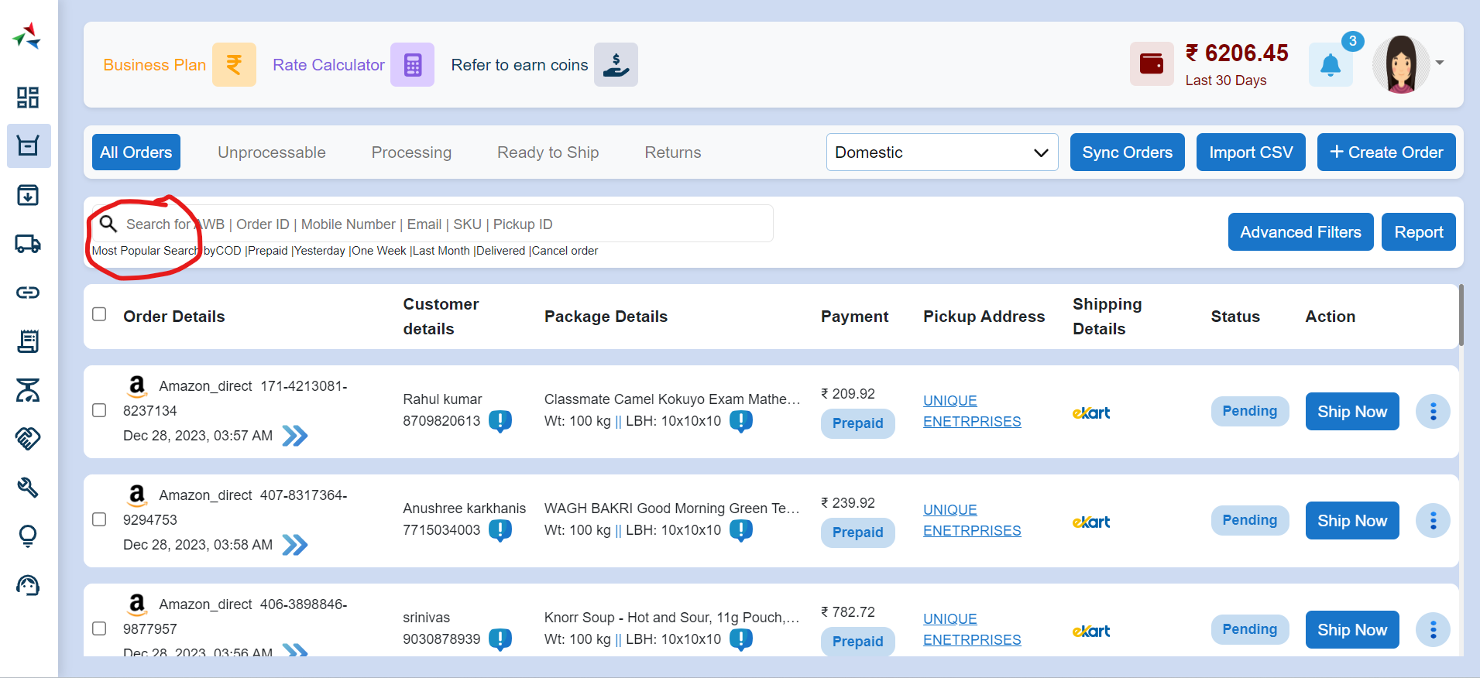

### **Example:**

* Navigate to the Order section.
* Click on the search icon.
* Enter the desired search criteria, such as AWB, Order ID, Mobile Number, Email, SKU, or Pickup ID.
* Press "Enter" or click the search icon to execute the search.
* Review the search results and click on a specific order to access detailed information.

## 3.2 Unprocessable Orders

The "Unprocessable Orders" section focuses on orders that require special attention or are currently unable to proceed through standard processing

**Features:**

* Reasons for Unprocessable Status
* Manual Review and Processing

## 3.3 Processing Orders

The "Processing Orders" section details the steps involved in handling orders that are currently being processed

**Features:**

* Order Verification
* Inventory Allocation
* Order Fulfilment
* Real-time Status Updates

## 3.4 Ready to Ship

The "Ready to Ship Orders" section covers the final stages of order preparation before shipping

**Features:**

* Label Generation
* Courier Selection
* Shipment Scheduling

## 3.5 Return

The "Return in Logistic" section provides guidance on handling product returns efficiently

**Features:**

* Return Authorization
* Inventory Restocking
* Reshipment Options

## 4. More on Orders

More on Orders guide users through advanced functionalities such as quick order processing, reassignment, merging, splitting, and order reversal

## 4.1 Quick Orders

The "Quick Orders" section outlines the process of quickly processing orders for time-sensitive scenarios

**Features:**

* Rapid Order Entry
* Minimal Verification Steps

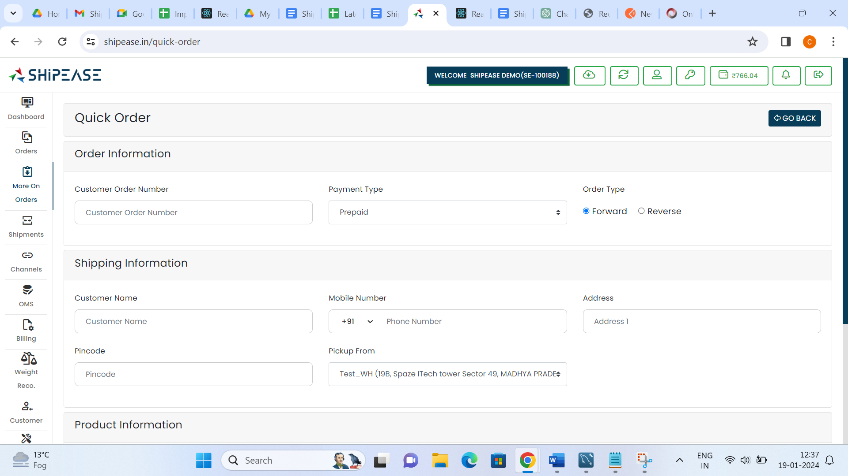

## 4.2 Reassign Orders

The "Reassign Orders" section focuses on the capability to reassign orders to different logistics teams or personnel

**Features:**

* Order Reassignment Options
* Notification to Original and New Assignees
* Tracking Order Reassignment History

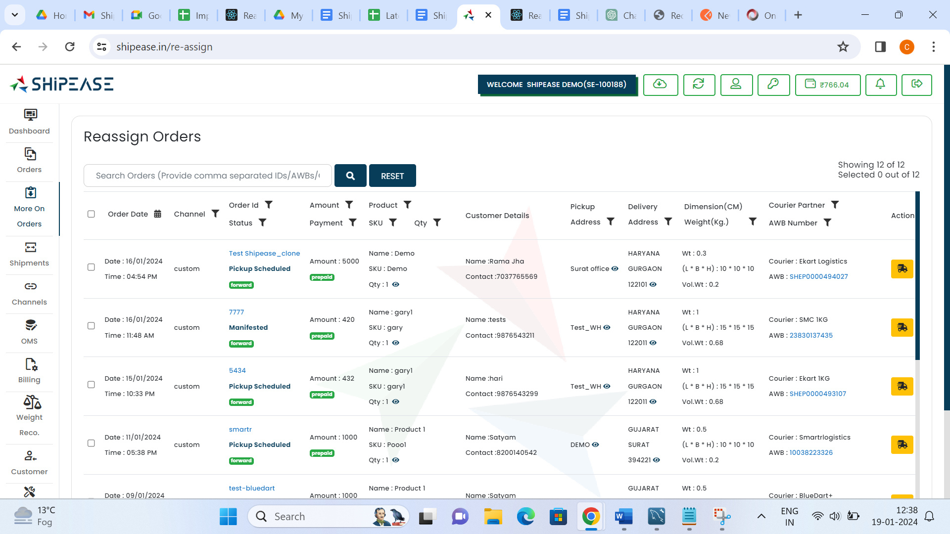

## 4.3 Merge Orders

The "Merge Orders" section provides guidance on merging multiple orders into a single order for streamlined processing

**Features:**

* Criteria for Merging Orders
* Consolidated Shipment Process
* Order Status Update for Individual and Merged Orders

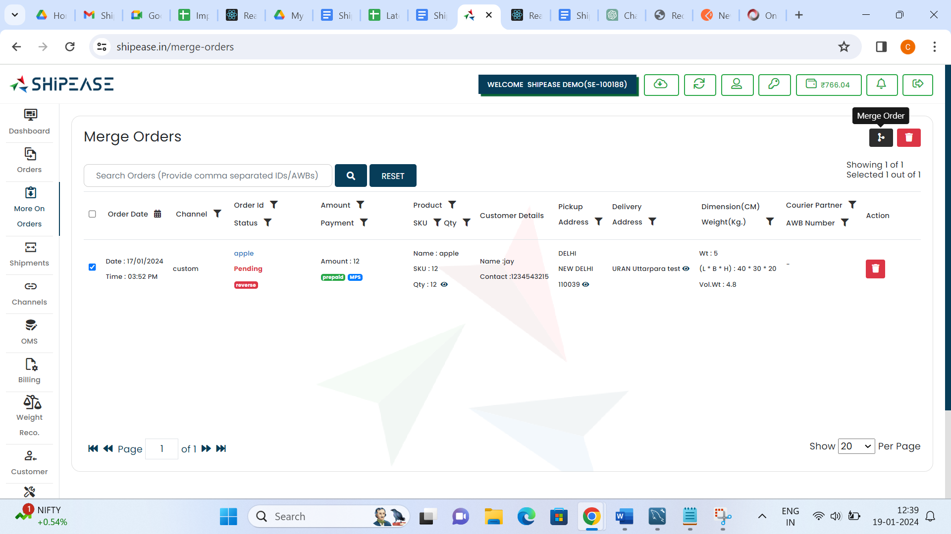

## 4.4 Split Orders

The "Split Orders" section covers the process of splitting a single order into multiple orders, typically for efficient fulfilment

**Features:**

* Split Criteria Definition
* Individual Shipment Handling
* Order Status Updates for Original and Split Orders

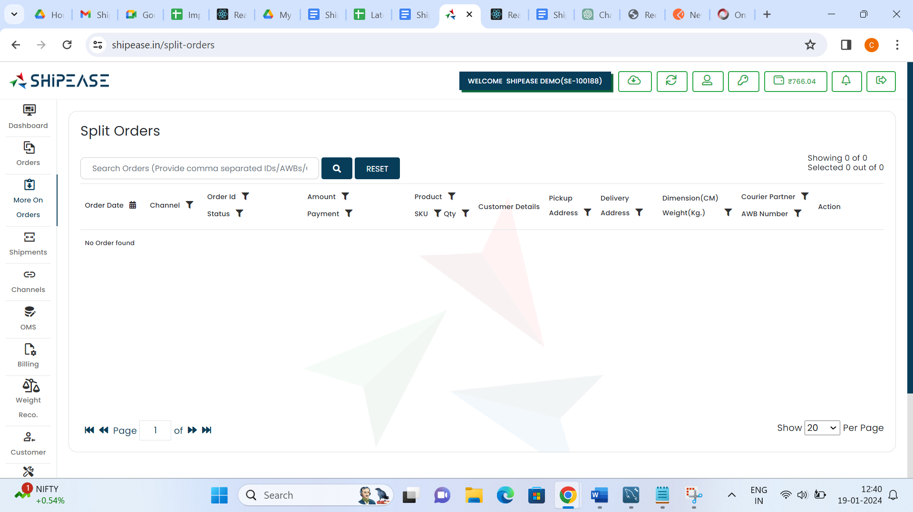

## 4.5 Reverse Orders

The "Reverse Orders" section explains the procedure for reversing the processing of an order in case of errors or cancellations

**Features:**

* Reverse Order Criteria
* Inventory Adjustment
* Refund Processing
* Order Status Update for Reversed Orders

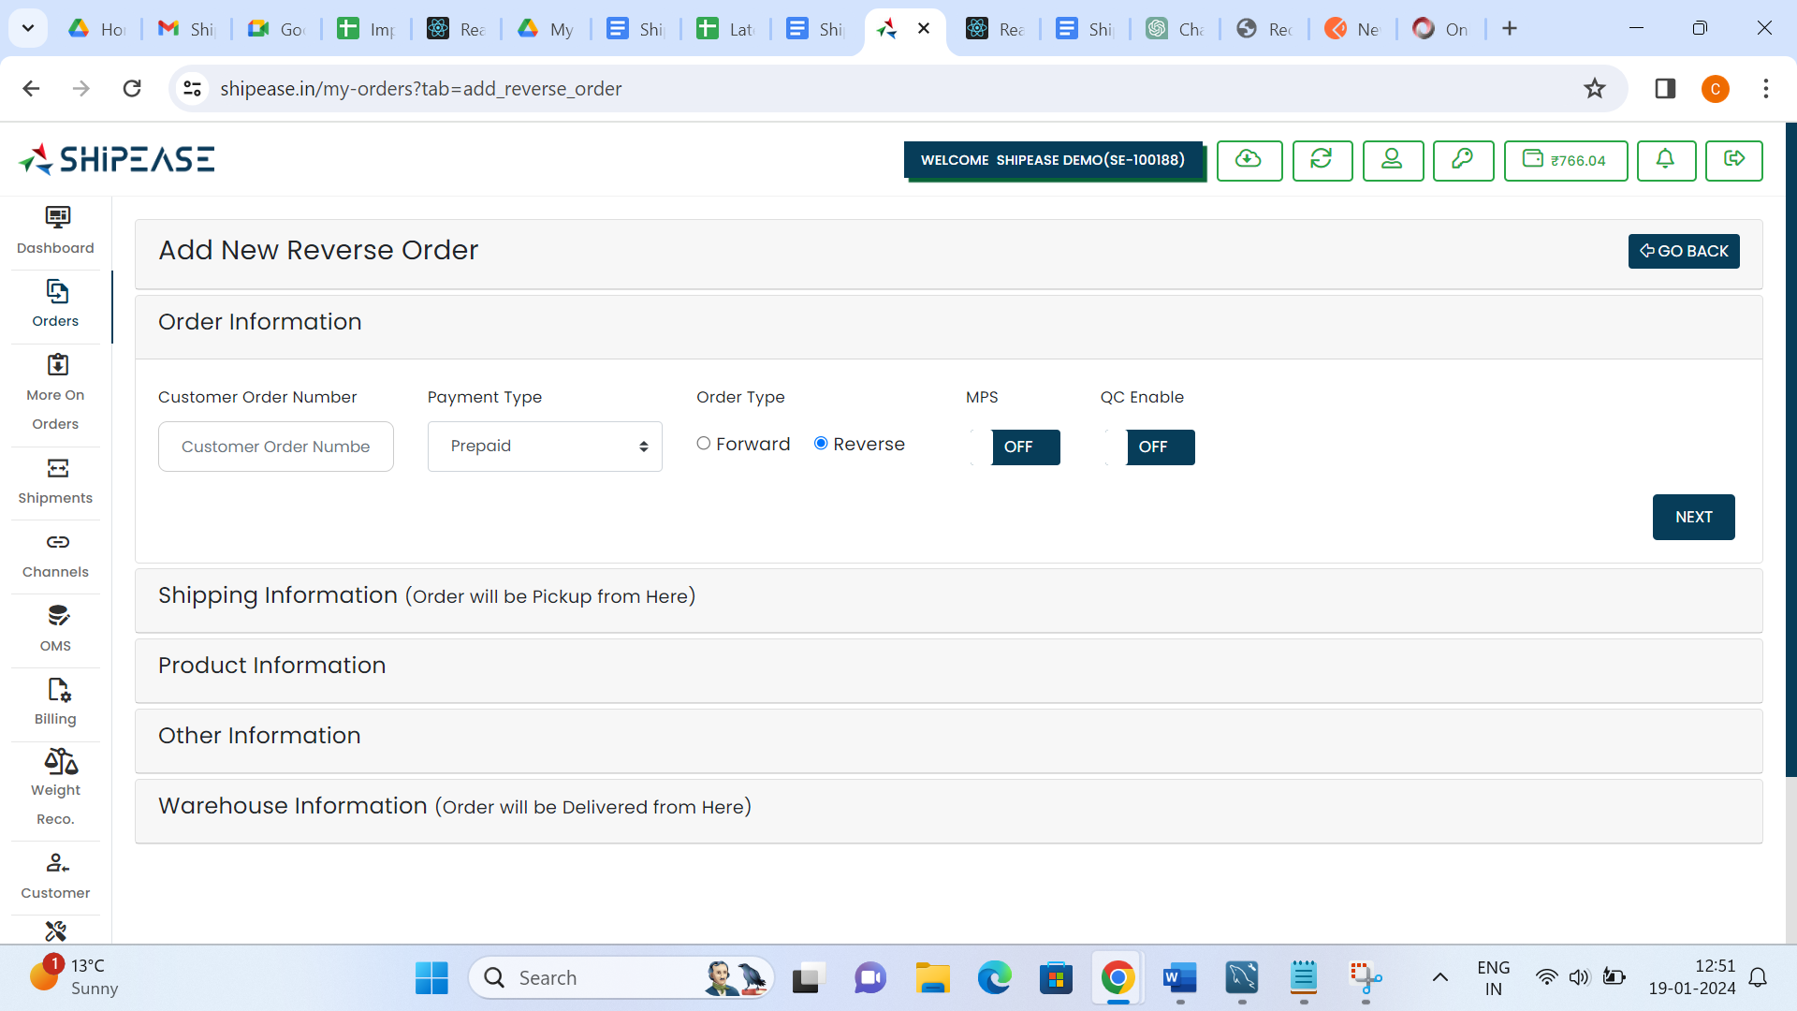

## **5. Shipment**

The Shipment Status provides detailed information on different shipment statuses within the logistics domain

## 5.1 Action Required

The "Action Required" status indicates that immediate attention or action is needed for a particular shipment. This section explains the scenarios leading to this status and the necessary actions to be taken

**Conditions:**

* Address Validation Issues
* Special Instructions for Delivery

**Actions:**

* Address Verification
* Communication with Stakeholders

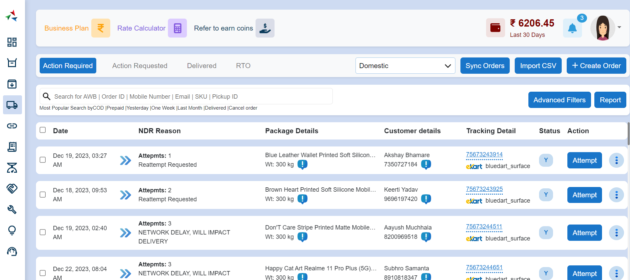

## 5.2 Action Requested

The "Action Requested" status indicates that specific actions are requested from the recipient or another party involved in the shipment. This section outlines the scenarios requiring actions and the steps to be taken

**Conditions:**

* Recipient Unavailable
* Additional Delivery Instructions Needed
* Payment Confirmation Required

**Actions:**

* Contacting Recipient
* Providing Additional Instructions
* Verifying Payment Information

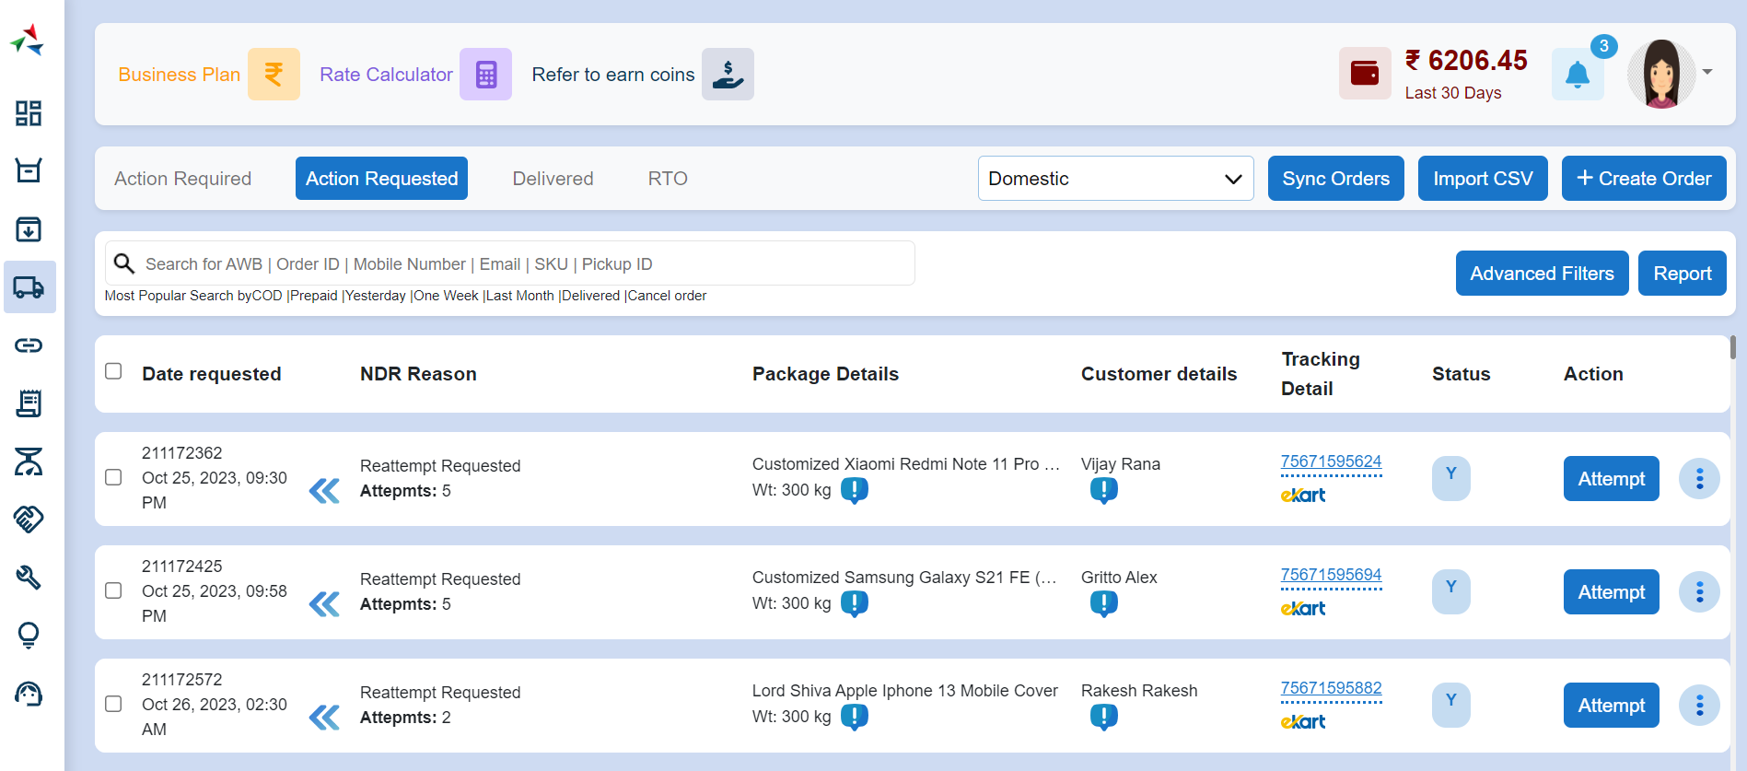

## 5.3 Delivered

The "Delivered" status signifies that the shipment has been successfully delivered to the intended recipient. This section provides details on confirming delivery, updating records, and handling post-delivery tasks

**Conditions:**

* Shipment Successfully Delivered

**Actions:**

* Updating Shipment Records
* Confirming Delivery with Recipient

## 5.4 Return to Origin (RTO)

The "Return to Origin (RTO)" status indicates that the shipment is being returned to the origin due to various reasons

**Conditions:**

* Unsuccessful Delivery Attempts
* Recipient Refusal
* Undeliverable Address

**Actions:**

* Scheduling RTO Pickup
* Restocking Inventory
* Reshipment Options

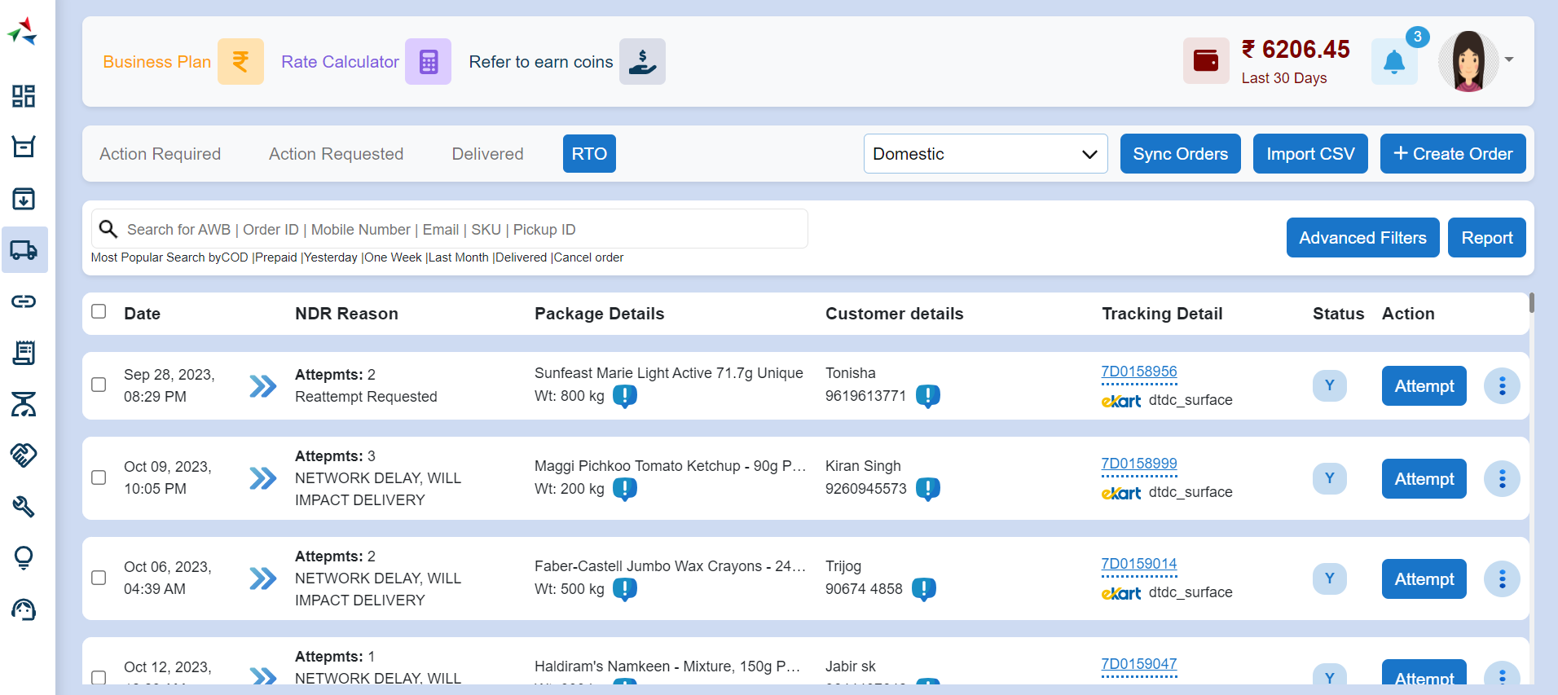

## 6. Integration

The Integration Information provides comprehensive information on integrating the logistics system with various external entities

## 6.1 Channels Integration

The "Channels Integration" section covers the process of integrating the logistics system with different sales channels, such as e-commerce platforms, marketplaces, and retail systems

**Features:**

* Channel Setup and Configuration
* Order Syncing
* Inventory Management
* Real-time Updates

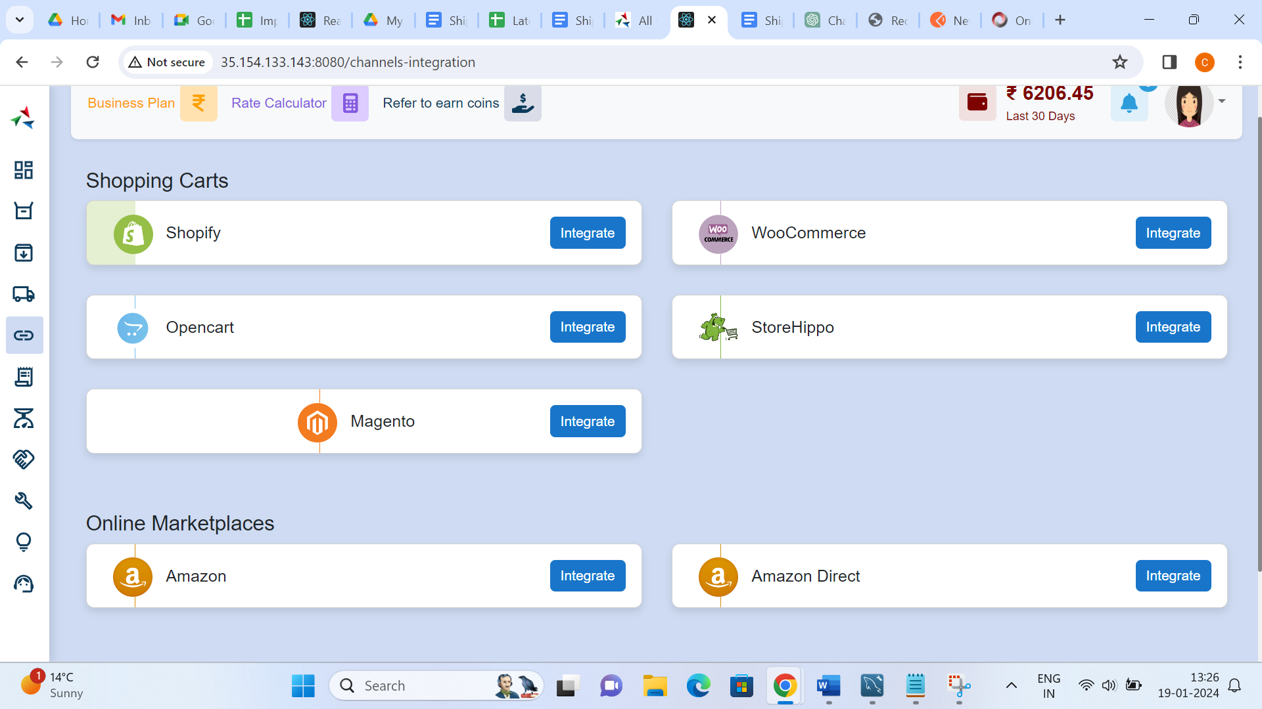

## 6.2 Order Management System (OMS)

The "Order Management System (OMS) Integration" section details the integration with OMS to ensure seamless order processing and synchronization of order data

**Features:**

* OMS Configuration
* Order Data Sync
* Order Status Updates
* Streamlined Order Fulfilment

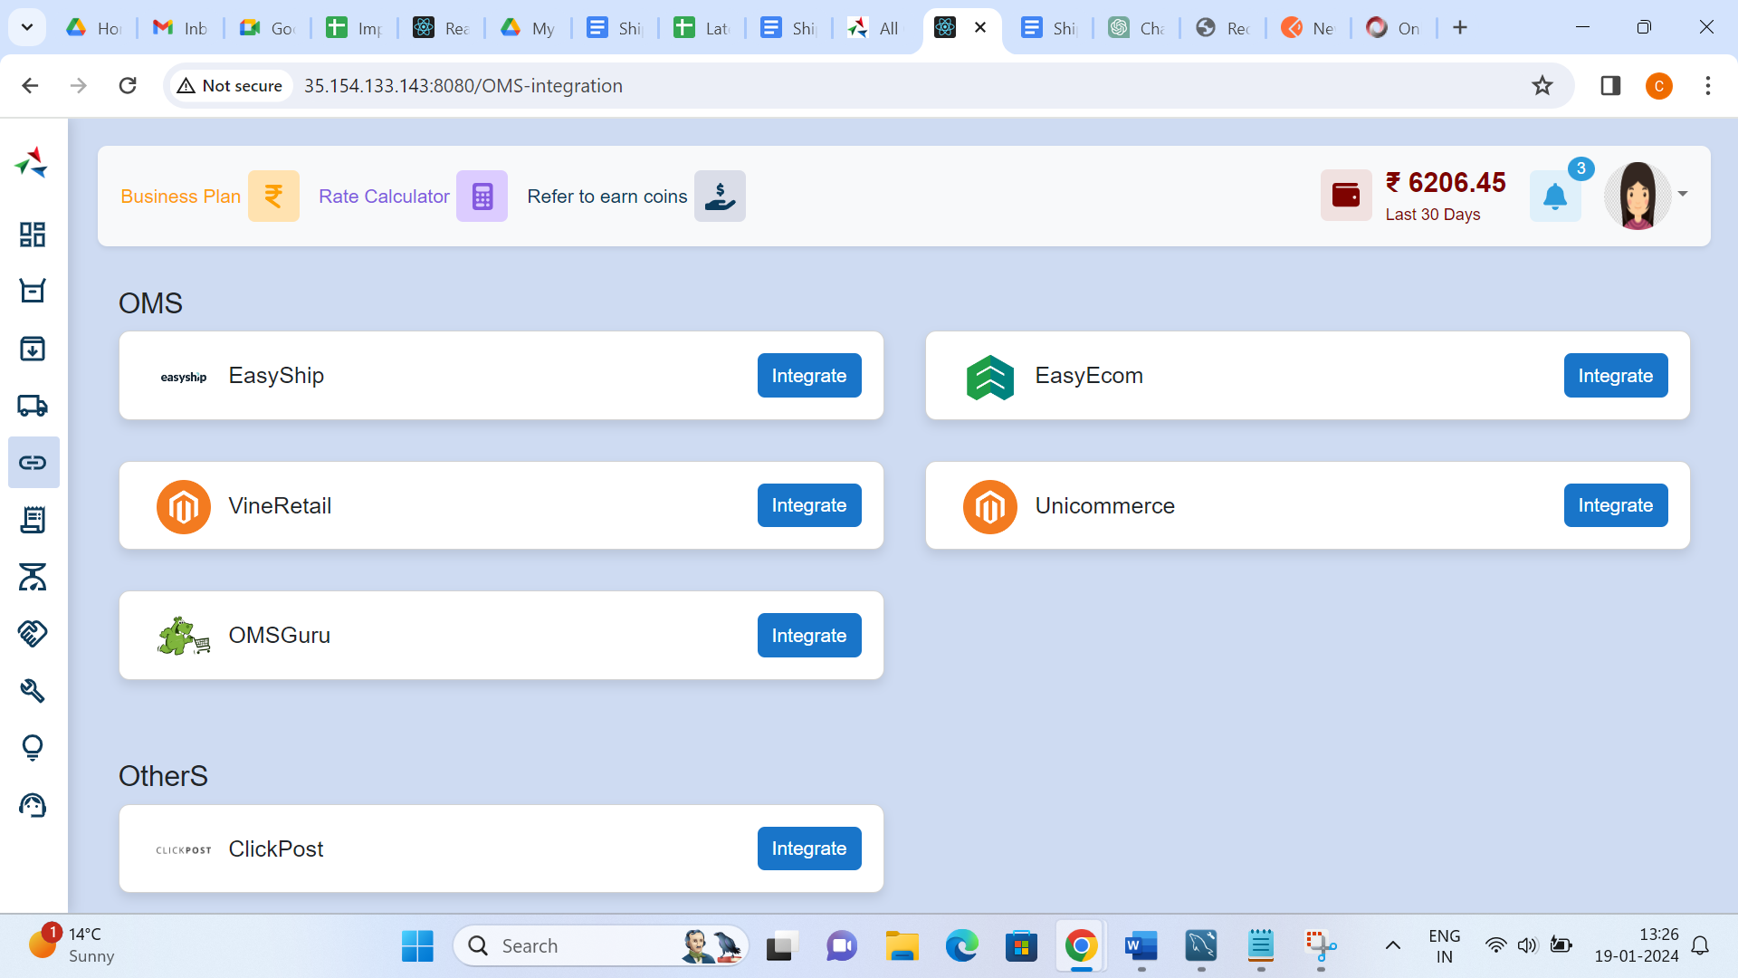

## 6.3 Couriers Integration

The "Couriers Integration" section outlines the integration with various courier services to streamline shipping processes, label generation, and real-time tracking

**Features:**

* Courier Selection Configuration
* Label Generation
* Shipment Tracking
* Rate Comparison

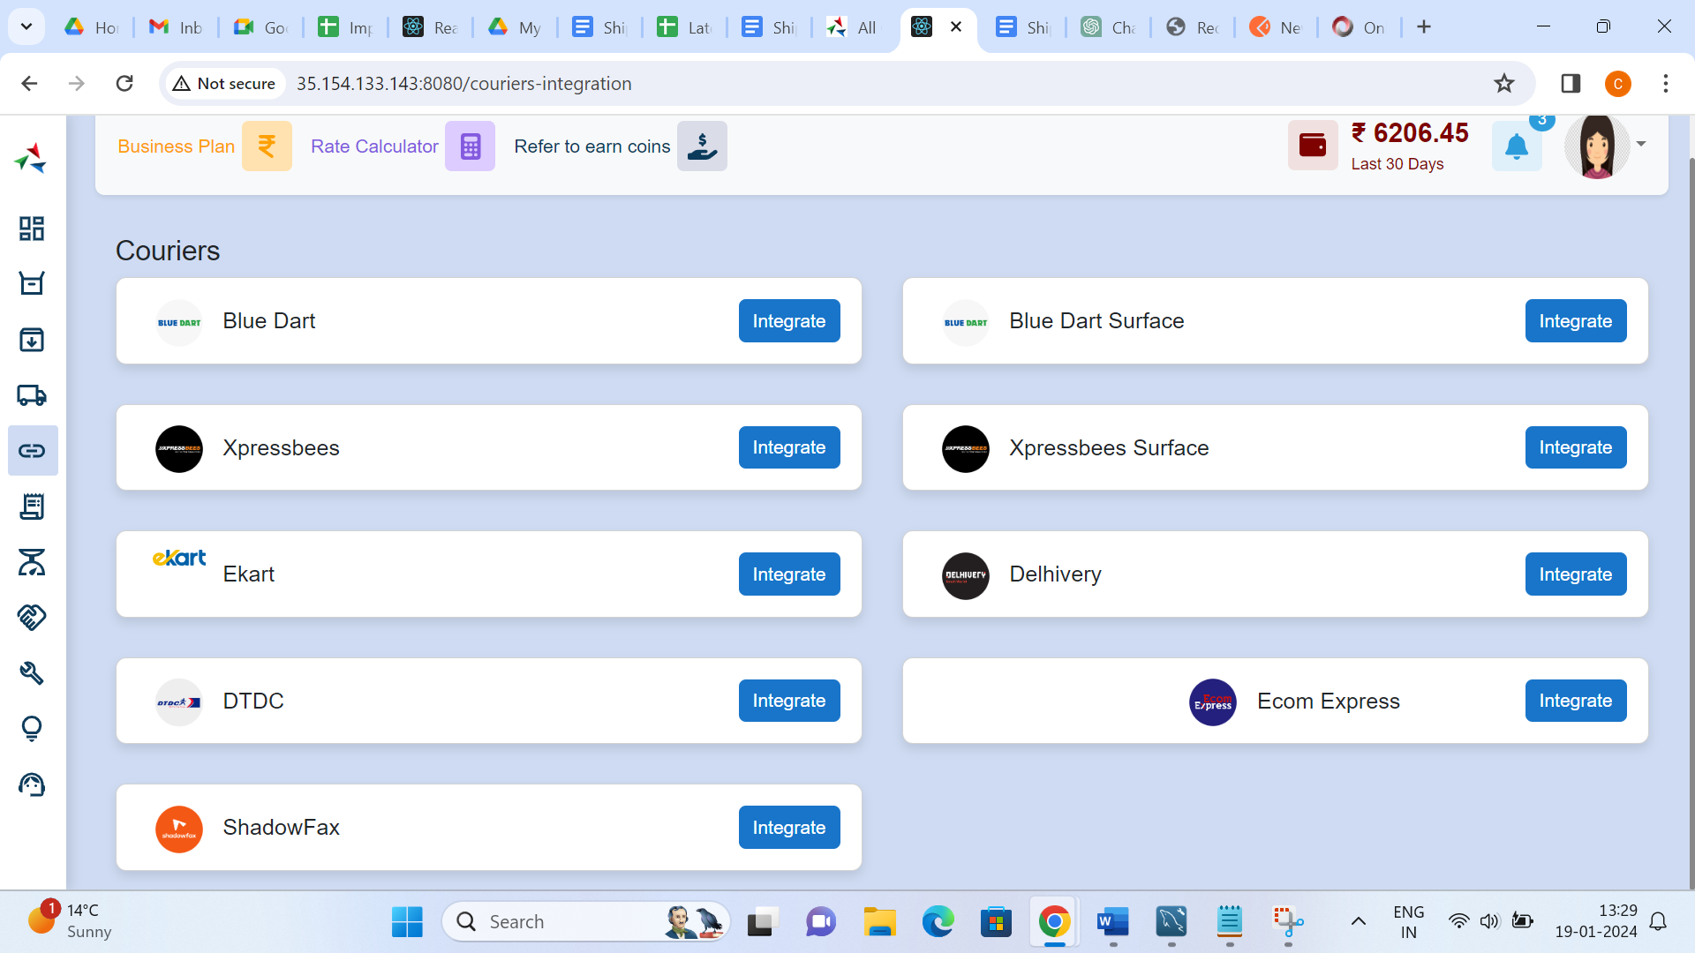

## 6.4 API Integration

The "API Integration" section provides details on integrating the logistics system with external systems using APIs, enabling seamless data exchange

**Features:**

* API Endpoint Configuration
* Data Syncing
* Authentication and Authorization
* Error Handling and Logging

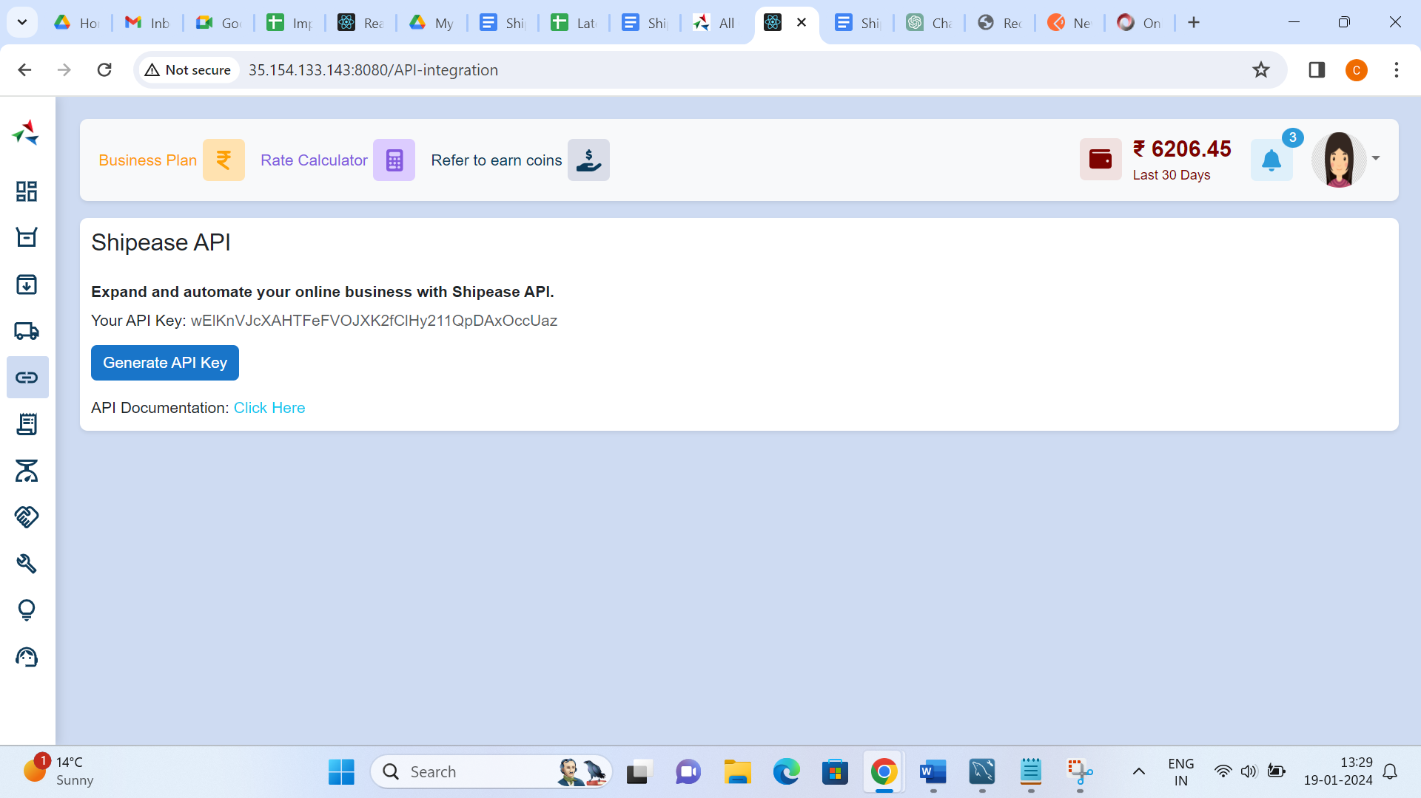

## 6.5 Other Integrations

The "Other Integrations" section covers additional integrations that may be specific to the logistics system, such as payment gateways, accounting software, or CRM systems

**Features:**

* Additional Integrations Configuration
* Data Exchange
* Automated Workflows

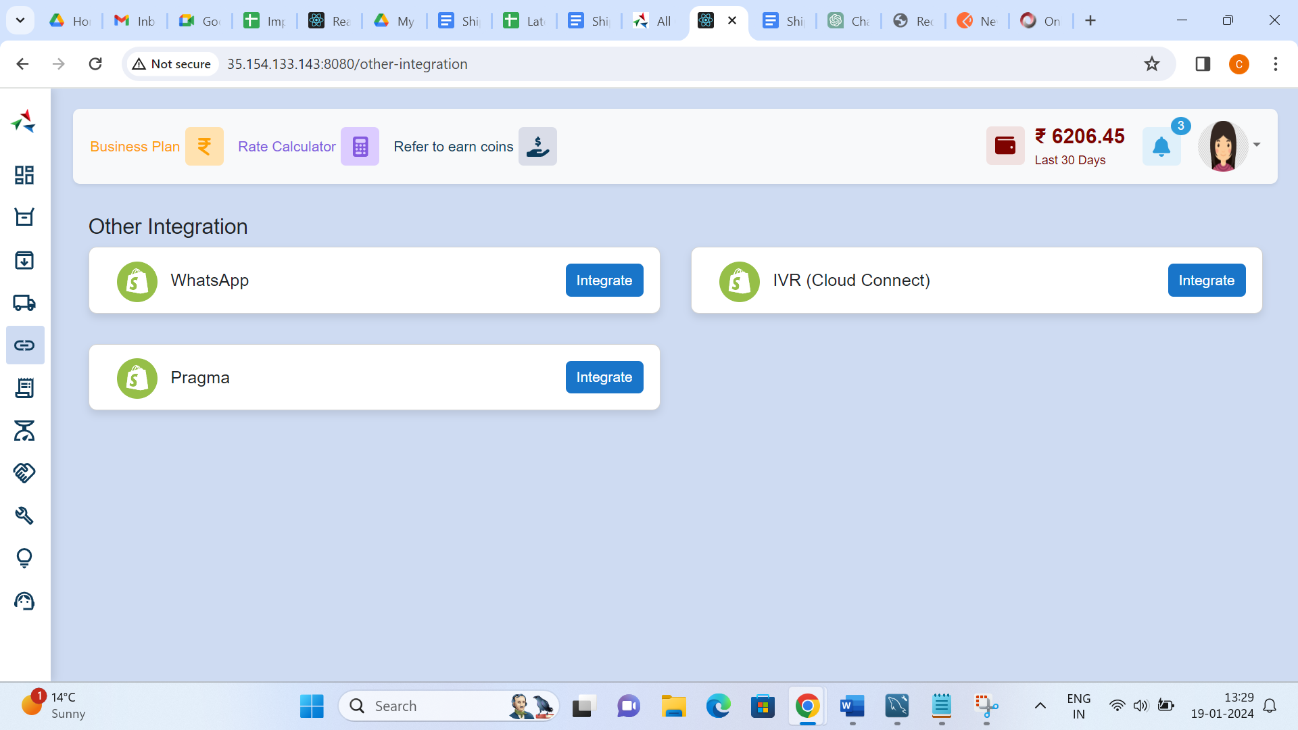

## 7. Billing

The Billing Documentation provides comprehensive information on the billing and financial aspects within the logistics domain

## 7.1 Shipping Charges

The "Shipping Charges" section covers the calculation, application, and management of shipping charges associated with logistics operations

**Features:**

* Shipping Cost Calculation
* Variable Shipping Rates
* Handling Shipping Discounts
* Transparent Communication of Shipping Charges

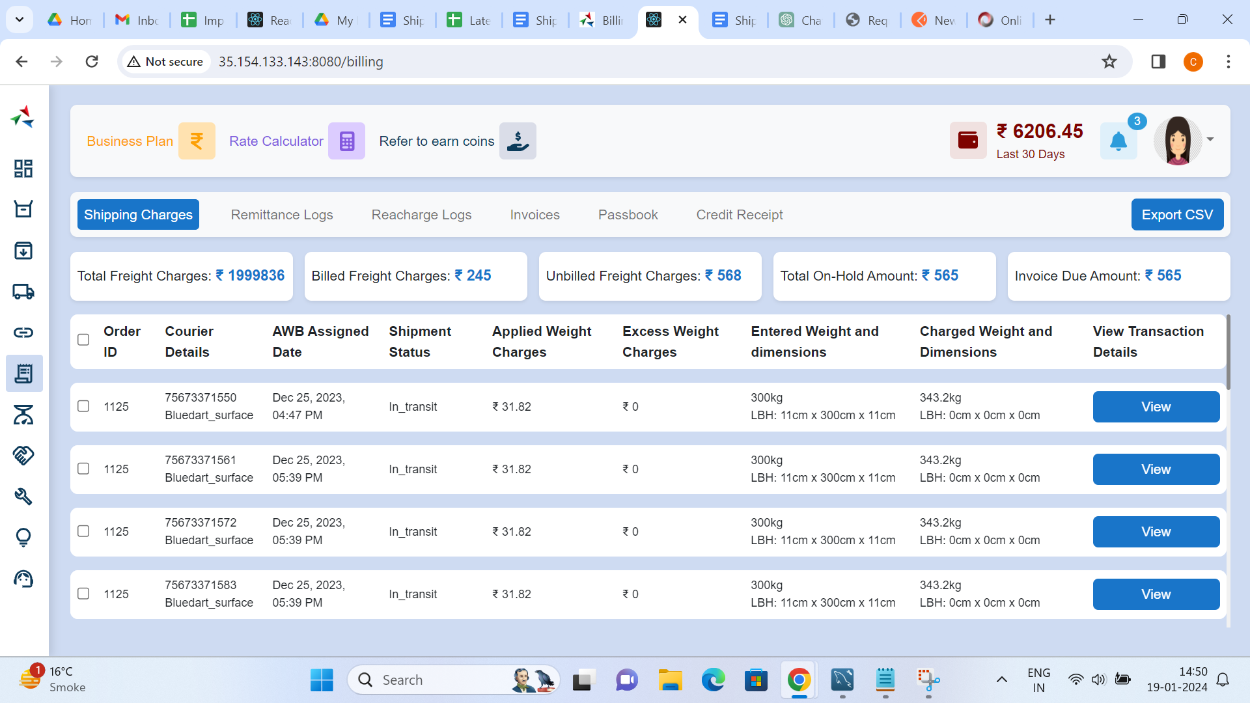

## 7.2 Remittance Logs

The "Remittance Logs" section details the tracking and logging of remittance transactions, providing transparency into financial activities

**Features:**

* Recording Remittance Transactions
* Transaction Details and History
* Integration with Financial Systems
* Payment status for each COD order

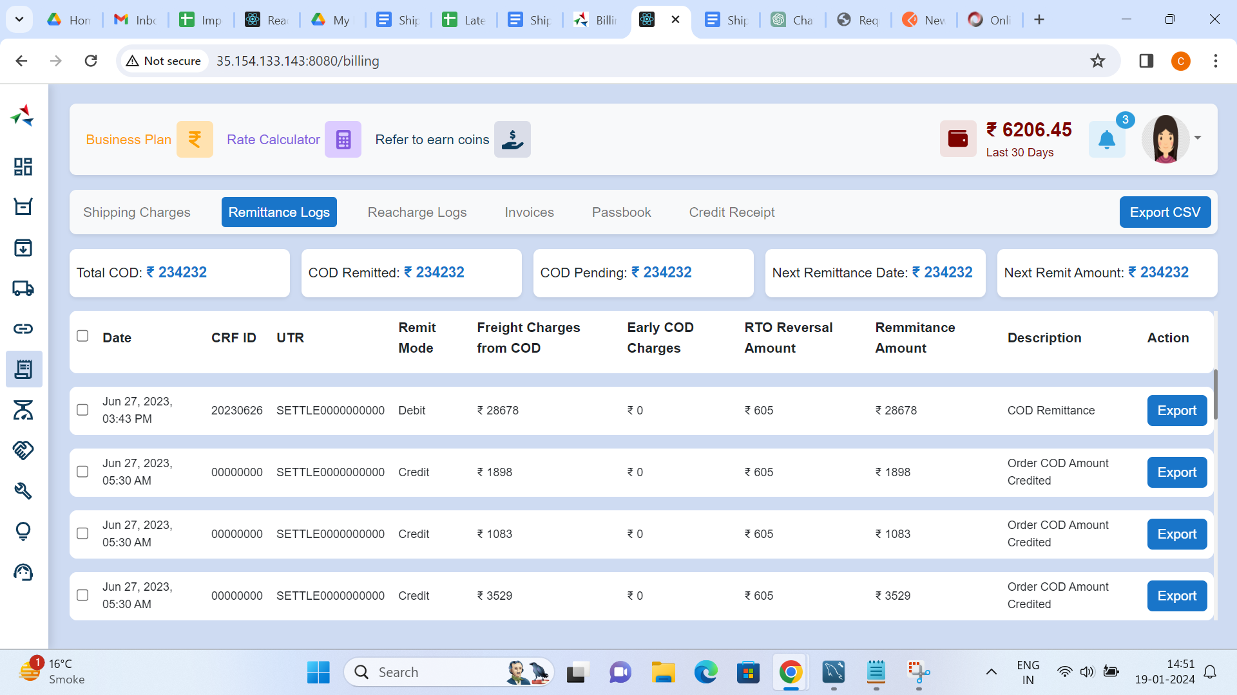

## 7.3 Recharge Logs

The "Recharge Logs" section explains the process of logging and tracking account recharges, ensuring a clear record of financial transactions

**Features:**

* Account Recharge Process
* Recharge Transaction Logs

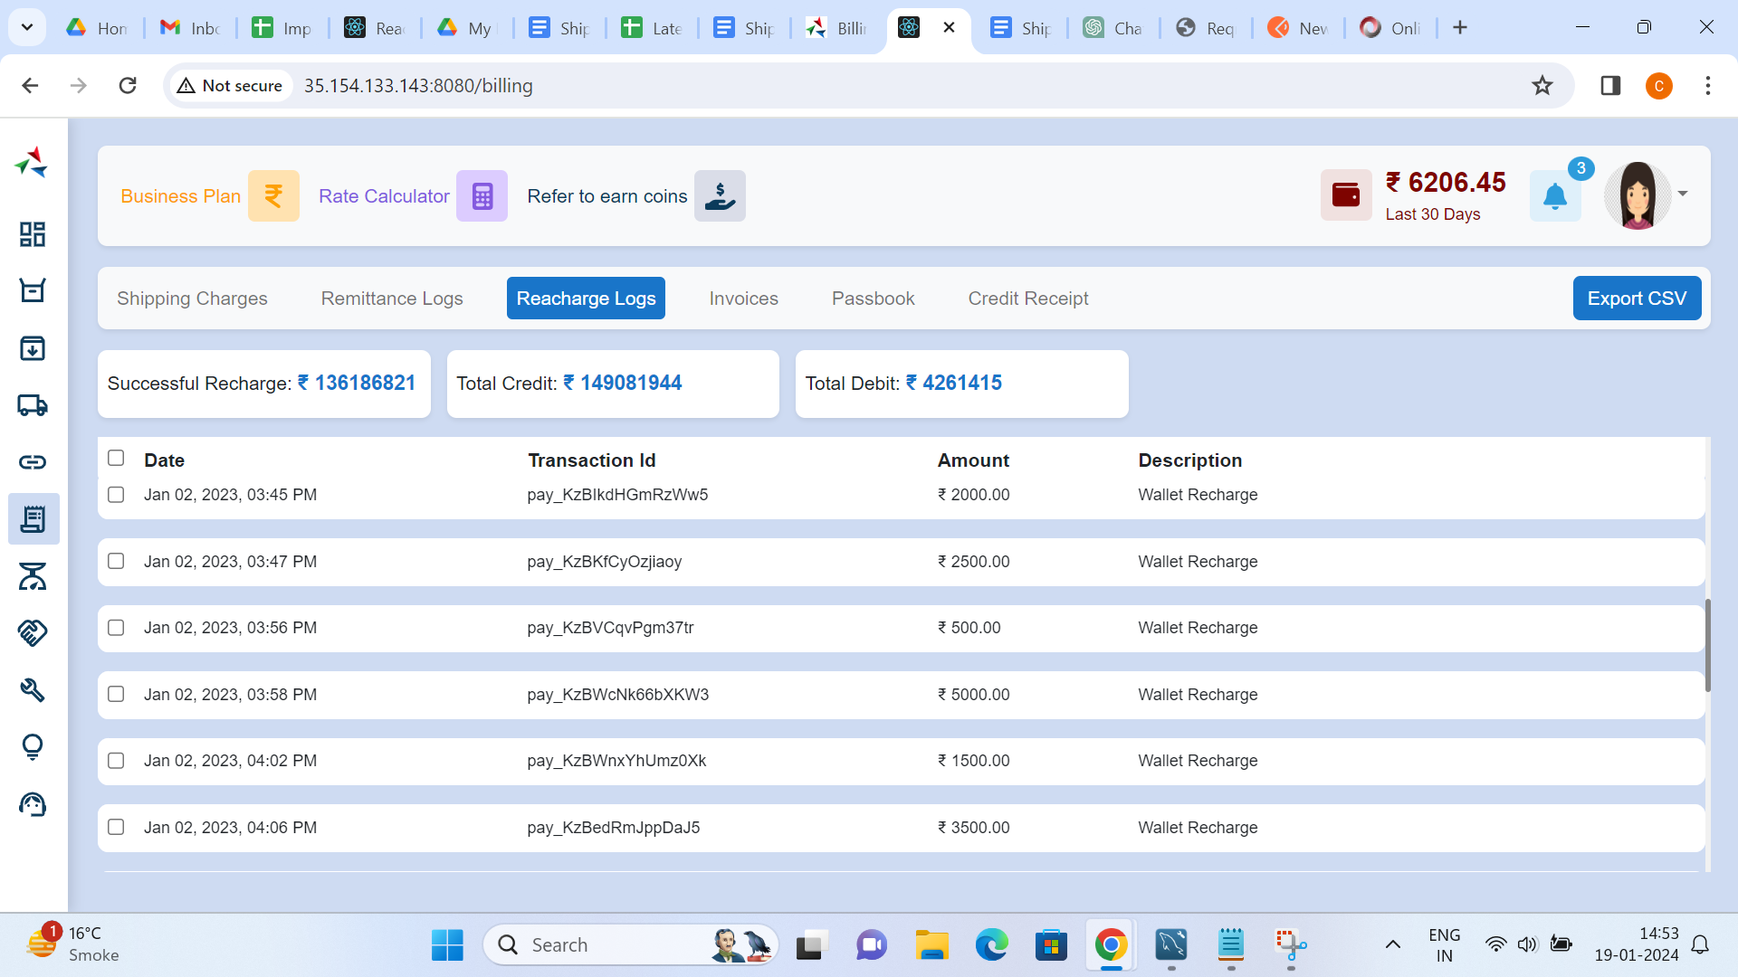

## 7.4 Invoices

The "Invoices" section outlines the generation and management of invoices for services provided, offering a detailed breakdown of charges

**Features:**

* Automated Invoice Generation
* Invoice Details and Line Items
* Invoice Delivery and Notification

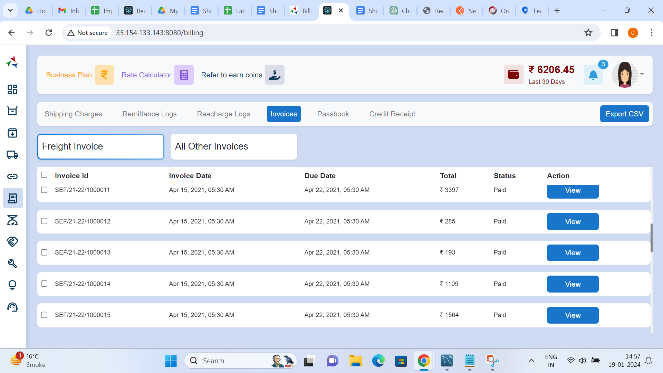

## 7.5 Passbook

The "Passbook" section provides users with a digital passbook that offers a chronological record of financial transactions, providing a clear overview of account activities

**Features:**

* Passbook Configuration
* Transaction History
* Real-time Passbook Updates

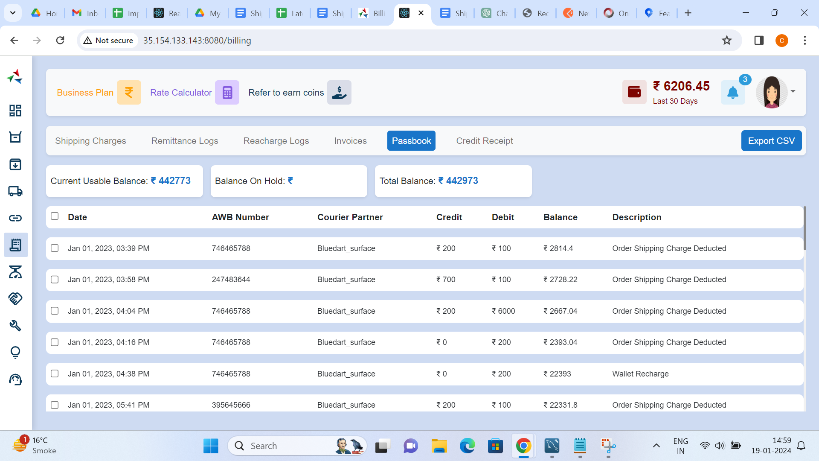

## 7.6 Credit Notes

The "Credit Notes" section covers the issuance and management of credit notes for refunds, adjustments, or other financial transactions

**Features:**

* Credit Note Generation
* Credit Note Details
* Application of Credit Notes

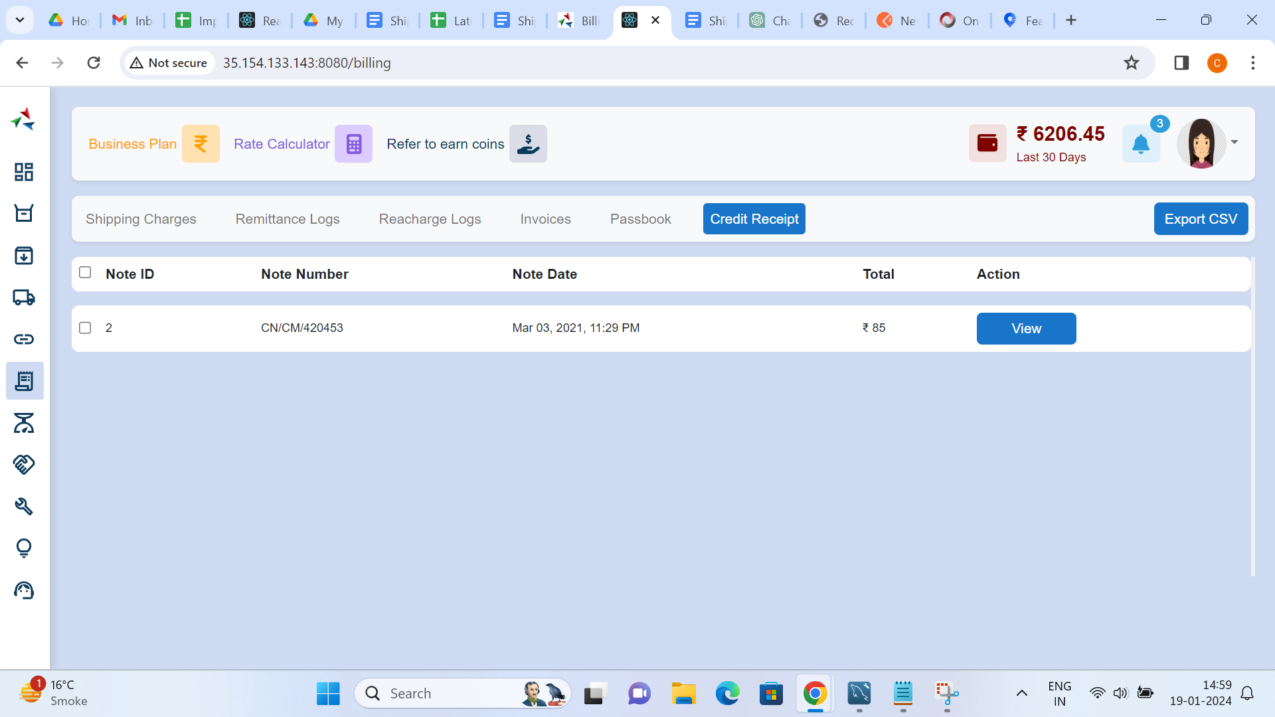

## 8. Weight Reconciliation

The Weight Reconciliation Documentation provides detailed information on reconciling weight-related data within the logistics domain

## 8.1 Reconciliations

The "Reconciliation" section explains the importance of reconciling weight data, ensuring accuracy in recorded weights, and resolving any discrepancies

**Features:**

* Weight Data Comparison
* Automated Reconciliation Processes
* Identification of Discrepancies
* Resolution Mechanisms

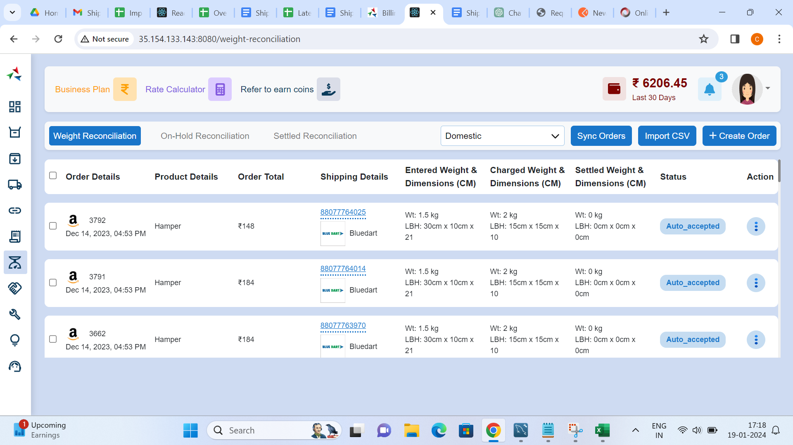

## 8.2 On Hold Reconciliation

The "On Hold" section outlines the process of placing weight-related data on hold, typically when discrepancies or issues are identified during reconciliation

**Features:**

* Identifying Weight Discrepancies
* Placing Items on Hold
* Notification Mechanisms
* Manual Review and Resolution

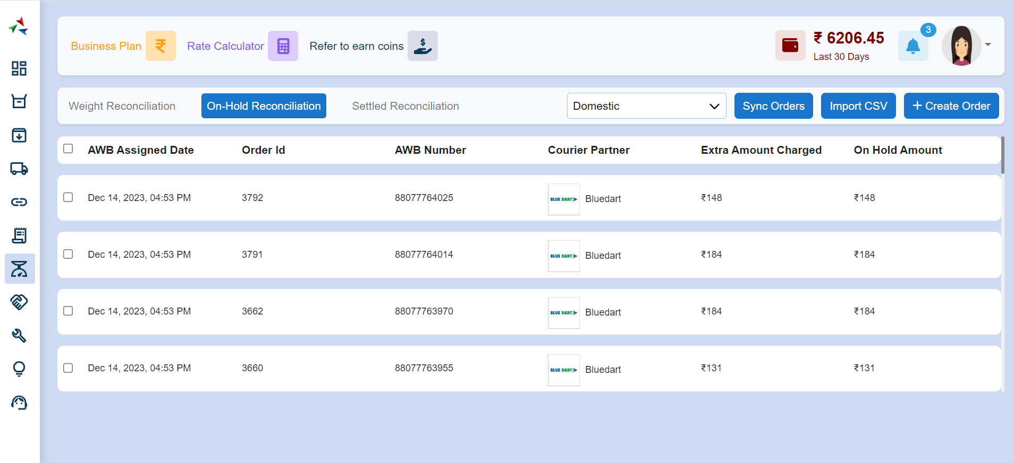

## 8.3 Settled Reconciliation

The "Settled" section covers the finalization of reconciled weight data, marking it as settled after discrepancies have been resolved and adjustments made

**Features:**

* Confirming Reconciliation
* Finalizing Weight Data
* Updating System Records
* Generating Settlement Reports

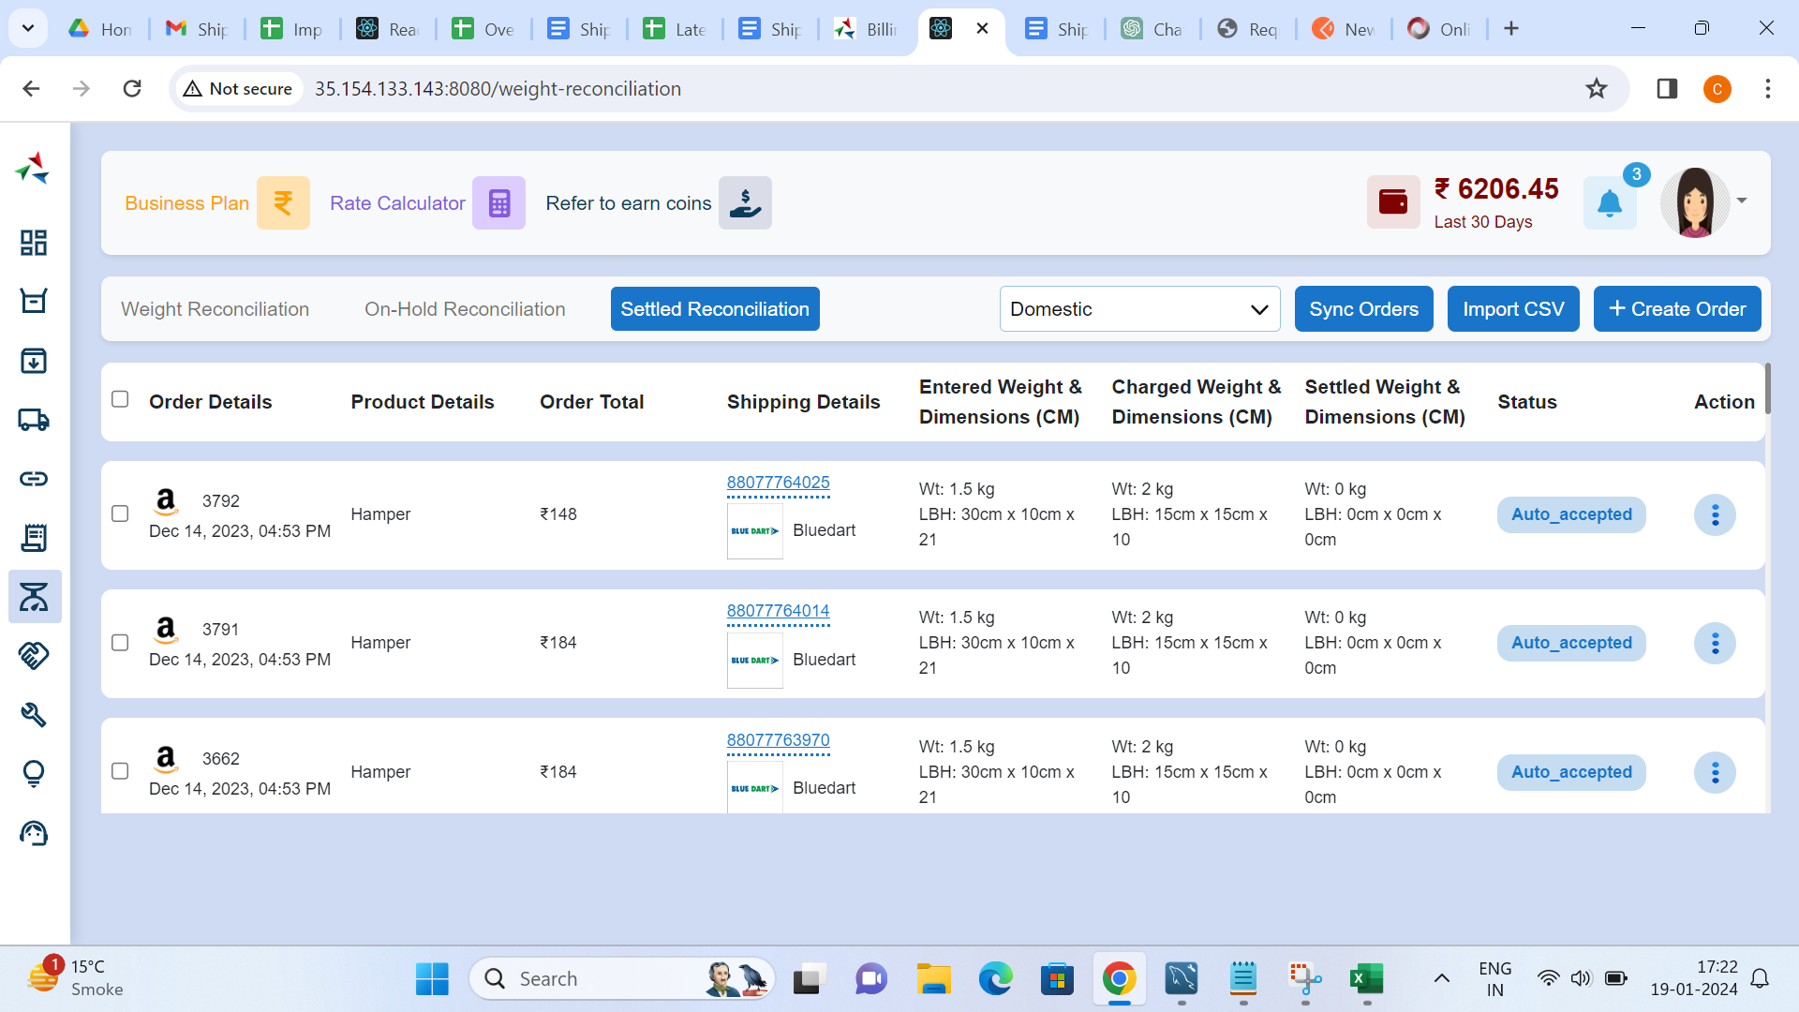

## 9. Customer

The Customer Management Documentation provides comprehensive information on managing customer data within the logistics domain

## 9.1 Basic Information

The "Basic Information" section covers the collection and management of essential details about customers

**Features:**

* Customer Registration
* Personal Information
* Contact Details
* Address Information

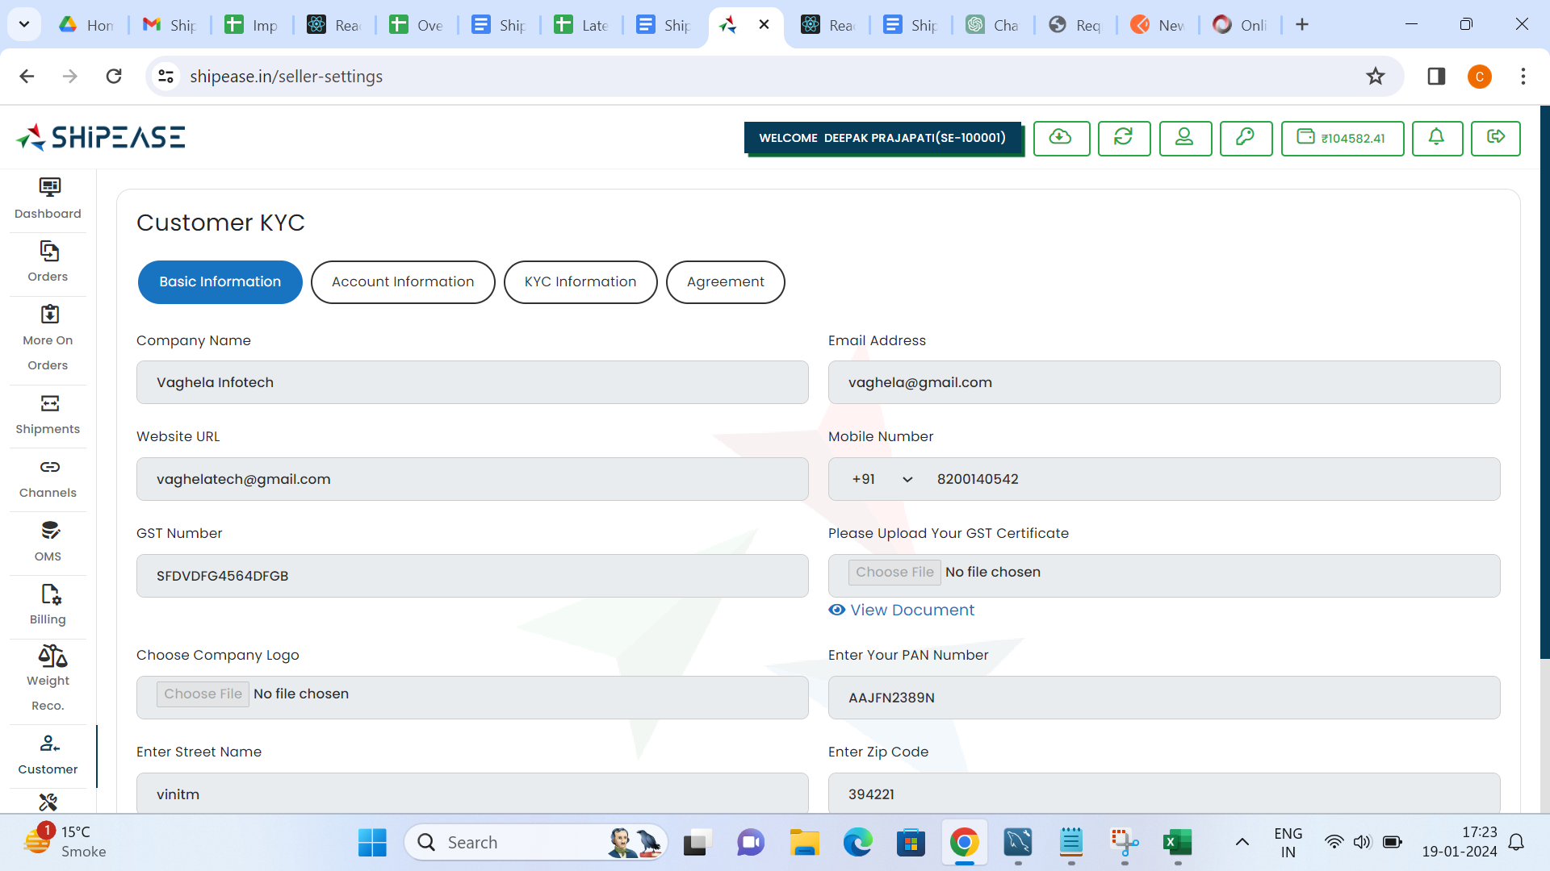

## 9.2 Account Information

The "Account Information" section provides details on managing customer accounts within the logistics system

**Features:**

* Account Details
* Account Status
* Banking details

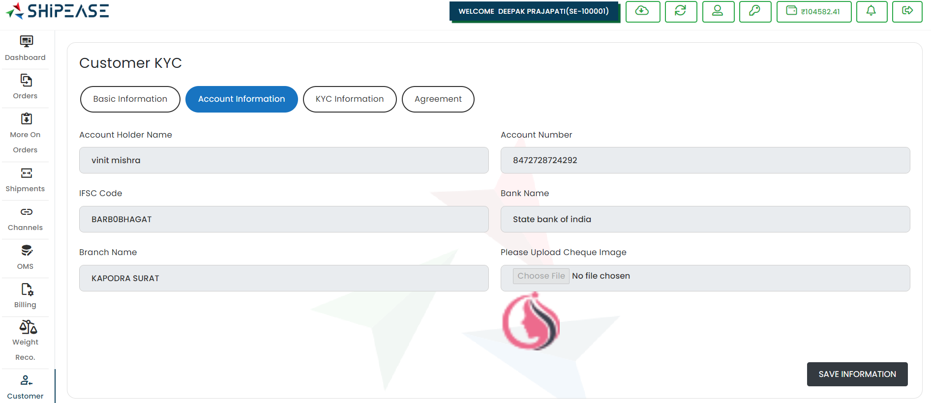

## 9.3 KYC Information

The "KYC Information" section outlines the process of collecting and verifying KYC data for customer identification and authentication

**Features:**

* Document Submission
* Verification Processes
* KYC Status Tracking

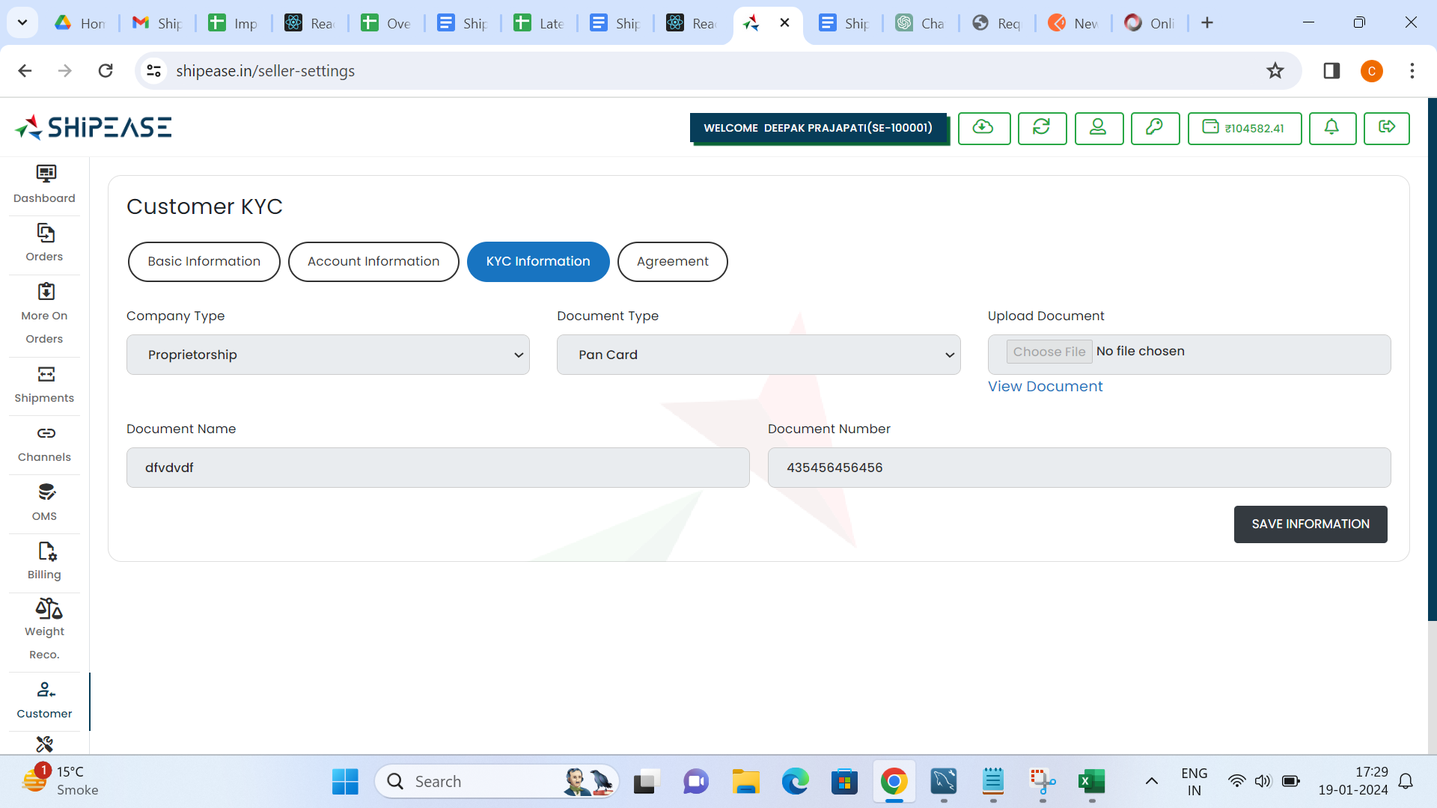

## 9.4 Agreement

The "Agreement" section covers the management of agreements and contracts with customers

**Features:**

* Agreement Creation
* Terms and Conditions
* Agreement Status Tracking

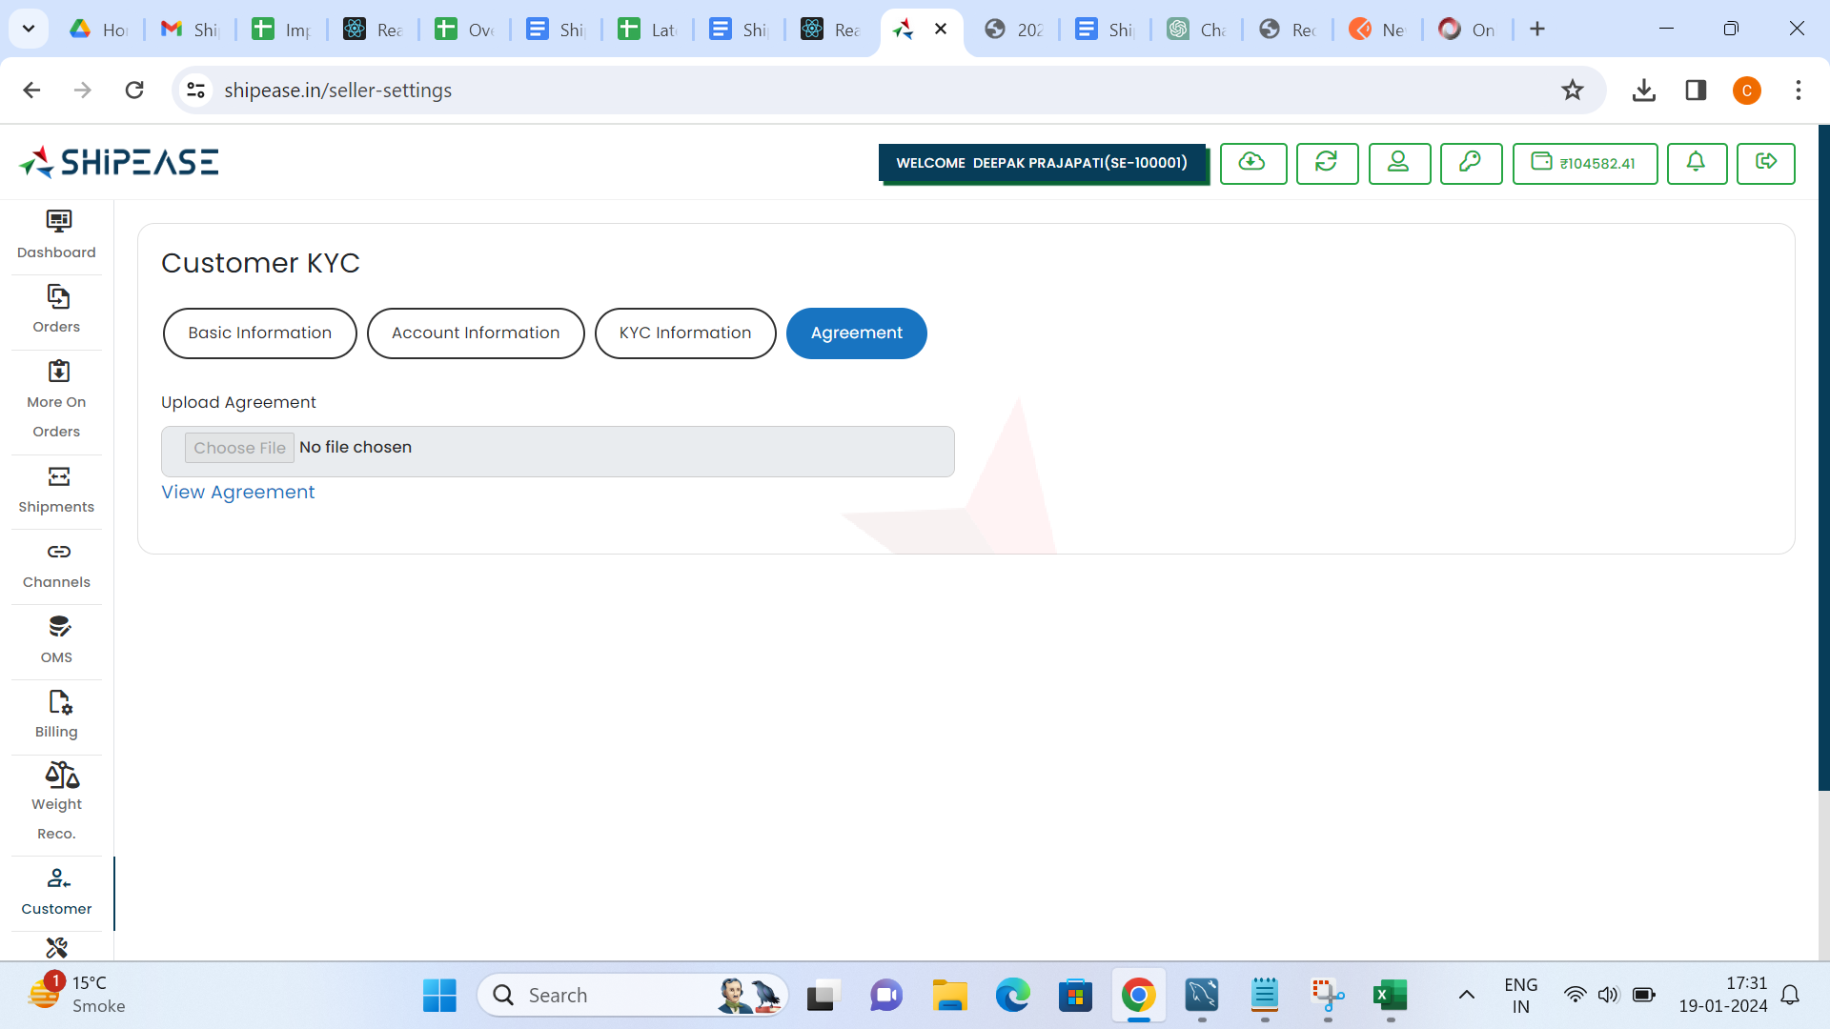

## 9.5 Employees

The "Employees" section provides information on managing employee data within the logistics system, particularly those associated with customer interactions

**Features:**

* Employee Profiles
* Assigned Roles and Responsibilities
* Employee-Customer Interaction History

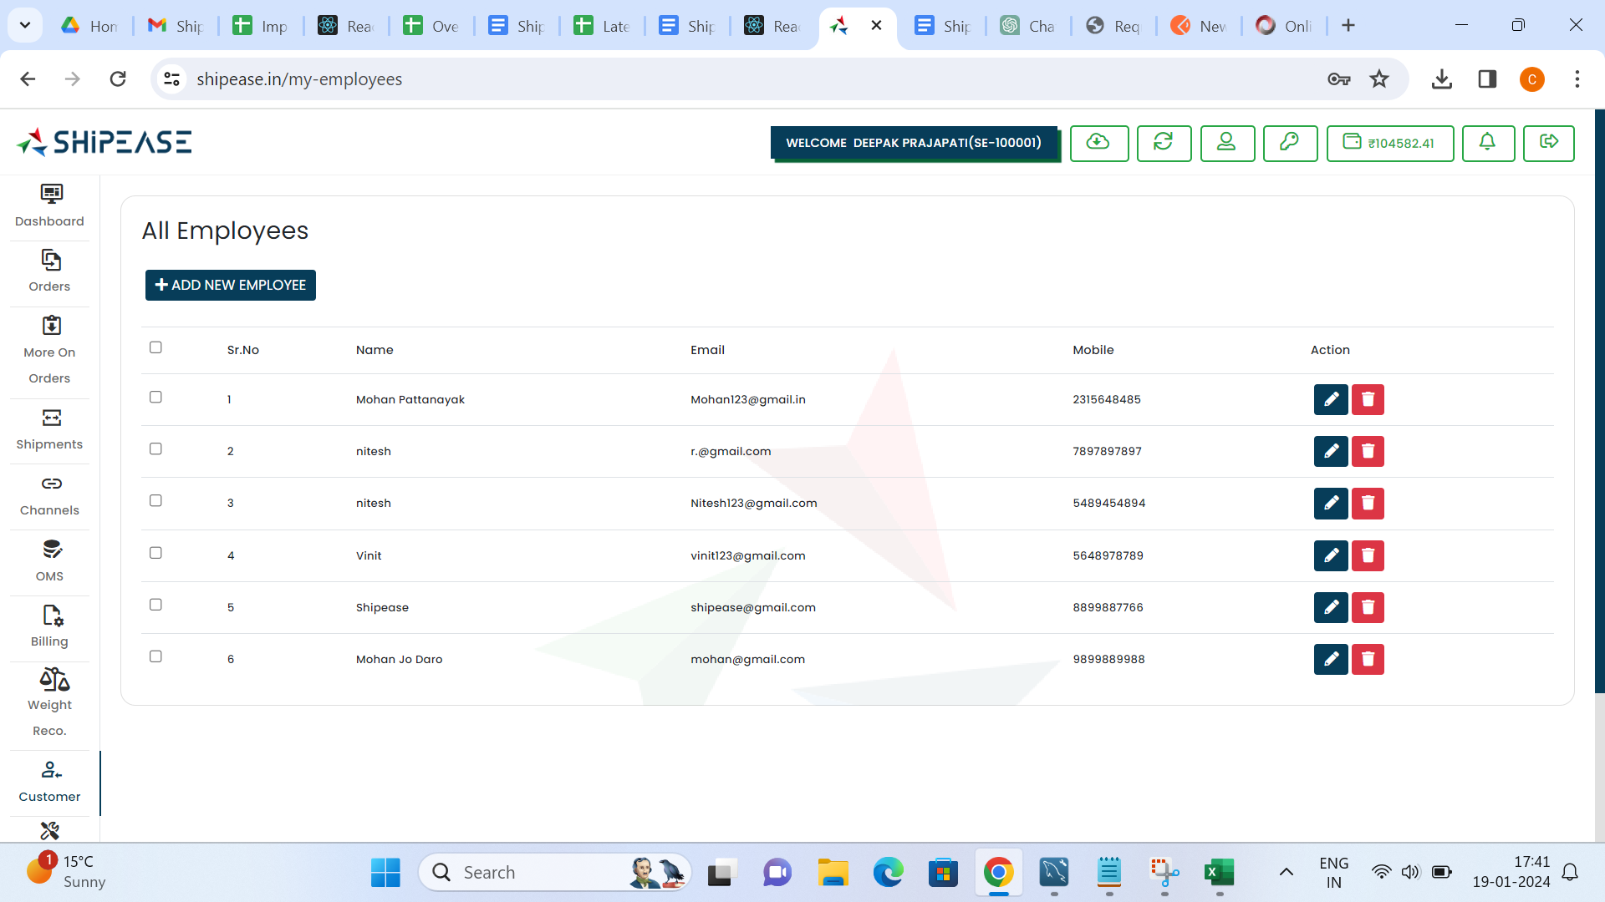

## 10. Tools

The Logistics Management Tools Documentation provides detailed information on essential tools within the logistics domain

## 10.1 Courier Preferences

The "Courier Preferences" tool allows users to configure and manage preferences related to courier services

**Features:**

* Courier Selection Criteria
* Default Courier Preferences

## 10.2 Warehouses

The "Warehouses" tool provides functionalities for managing and optimizing warehouse operations

**Features:**

* Warehouse Configuration
* Inventory Management
* Order Fulfilment from Warehouses
* Real-time Stock Updates

## 10.3 Rules

The "Rules" tool enables users to define and manage rules governing various aspects of logistics operations

**Features:**

* Business Rules Configuration
* Order Processing Rules
* Shipping Rule
* Courier Priority

## 10.4 SKU

The "SKU" tool facilitates the management of Stock Keeping Units, ensuring accurate tracking and control of inventory

**Features:**

* SKU Creation and Editing
* SKU Attributes
* SKU-Level Reporting

## 10.5 Shipping Rates

The "Shipping Rates" tool allows users to define and manage shipping rates for different destinations and courier services

**Features:**

* Shipping Rate Configuration
* Destination-based Rates
* Weight and Dimension Considerations

## 10.6 Rate Calculator

The "Rate Calculator" tool assists users in determining shipping costs for different scenarios based on configured rates

**Features:**

* Real-time Rate Calculation
* Rate Chart Comparison
* Integration with Shipping Rate Database
* Zone Mapping

## 10.7 Customize Label

The "Customize Label" tool allows users to personalize shipping labels according to branding and regulatory requirements

**Features:**

* Label Template Customization
* Branding Elements Inclusion
* Dynamic Label Generation

## 10.8 Branded Tracking

The "Branded Tracking" tool enhances the customer tracking experience by providing a branded and user-friendly interface

**Features:**

* Customized Tracking Page
* Branding Information
* Best Selling Products Information

## 11. MIS

The Management Information System (MIS) Documentation provides detailed information on the reporting features within the logistics domain

## 11.1 MIS Report

The "MIS Report" section outlines the process of generating comprehensive reports that provide insights into various aspects of logistics operations

**Features:**

* Report Categories
* Customizable Report Parameters
* Real-time Data Updates

## 11.2 Download Report

The "Download Report" section explains how users can download MIS reports for offline access, sharing, or further analysis

**Features:**

* Download Formats (e.g., PDF, Excel, CSV)
* Customized Report Downloads
* Scheduled Report Downloads

## 12. Customer Support

The Customer Support Documentation provides a comprehensive guide on addressing various customer-related issues within the logistics domain

## 12.1 Shipment Related Issue

The "Shipment Related Issue" section covers guidelines for handling customer queries or problems related to the shipment process

**Common Issues:**

* Delayed Shipments
* Missing or Damaged Items
* Address Errors
* Tracking Information Concerns

## 12.2 Pickup Related Issue

The "Pickup Related Issue" section outlines procedures for addressing concerns related to pick up services

**Common Issues:**

* Missed Pickups
* Schedule Changes
* Pickup Location Issues

## 12.3 Weight Related Issue

The "Weight Related Issue" section provides guidance on handling customer concerns regarding weight discrepancies

**Common Issues:**

* Incorrect Weight Calculation
* Discrepancies Between Shipped and Billed Weight

## 12.4 Tech Related Issue

The "Tech Related Issue" section addresses troubleshooting steps for technology-related problems raised by customers

Common Issues:

• Website Access Problems

• Technical Glitches During Order Placement

## 12.5 Billing and Remittance

The "Billing and Remittance" section guides customer support representatives in addressing inquiries related to billing and remittance processes

Common Issues:

* Invoice Discrepancies
* Delayed Payments
* Remittance Confirmation

## 12. Conclusion

In conclusion, this documentation serves as a guide to understanding and utilizing the Logistics Dashboard effectively. Regular updates and enhancements will be reflected in the documentation to ensure users have access to the latest features and functionalities